CSS ISLAMIC STUDIES · T7QA
بِسۡمِ ٱللَّهِ ٱلرَّحۡمَٰنِ ٱلرَّحِيمِ
Topic VII — Extremism, Terrorism, Sectarianism and Jihad
The Question Answers · Every past-paper question of Topic 7, 2015–2026, answered as a model
Eight model answers — Jihad and Fasad, the principles of Jihad, 'Is extremism a challenge to Islam?', the reasons and motives of extremism and terrorism in Pakistan in three different shapes, eliminating religious and political extremism through the Prophet's teachings, and sectarianism and polarisation. Each begins with an answer map that states exactly what the question asks.
Edition of September 2026 · covers the papers of 2015–2026 · written for CSS 2027 and after
Contents
HOW TO BUILD THE CONTENTS
The Contents below is left empty on purpose. In Microsoft Word, right-click anywhere on the grey line below and choose Update Field → Update entire table → OK. The full table of contents with page numbers will appear.
On a Mac: right-click (or Control-click) the line → Update Field. If you edit the notes later, repeat this step to refresh the page numbers. You can also press Ctrl + A then F9 (Windows) to update every field in the document at once.

How to Use These Answers 5
What is in this document 5
How every answer is built 5
Answer 1 · Jihad and Fasad; Jihad in Today's International Scenario (CSS 2015) 6
Decoding the question 6
The model answer 7
(1) Introduction 7
(2) The meaning of Jihad 7
(3) The meaning of Fasad 7
(4) The difference between Jihad and Fasad 9
(5) The practical application of Jihad in the current international scenario 9
(6) What is not Jihad 10
(7) Conclusion 11
Why this answer scores 11
Answer 2 · The Principles and Conditions of Jihad (CSS 2020) 12
Decoding the question 12
The model answer 12
(1) Introduction 12
(2) The kinds of Jihad 13
(3) The stages of the command 13
(4) The principles and conditions of armed Jihad 14
(5) Martyrdom and suicide 17
(6) Conclusion 17
Why this answer scores 17
Answer 3 · Is Extremism a Challenge to Islam? — In the Context of the Ummah's Challenges (CSS 2019) 18
Decoding the question 18
The model answer 18
(1) Introduction 18
(2) What extremism is 19
(3) Islam's position — the middle path 19
(4) The first extremists — the Khawarij 20
(5) Why extremism is a challenge to Islam 20
(6) How extremism multiplies the Ummah's other challenges 21
(7) The Ummah's response 21
(8) Conclusion 22
Why this answer scores 22
Answer 4 · Reasons of Extremism in Pakistan and Solutions in the Light of Islam (CSS 2017) 23
Decoding the question 23
The model answer 23
(1) Introduction 23
(2) The reasons of extremism in Pakistan 24
(3) The solutions in the light of Islamic teachings 25
(4) The national measures 28
(5) Conclusion 29
Why this answer scores 29
Answer 5 · The Motives of Terrorism in Pakistan and How Society Can Get Rid of It (CSS 2018) 30
Decoding the question 30
The model answer 30
(1) Introduction 30
(2) The phases of terrorism in Pakistan 31
(3) The motives of terrorism 31
(4) Islam's verdict on terrorism 32
(5) How society can get rid of terrorism 33
(6) The role of the state 34
(7) Conclusion 34
Why this answer scores 35
Answer 6 · The Motives of Extremism and How Society Can Get Rid of It by Following Islam (CSS 2023) 36
Decoding the question 36
The model answer 37
(1) Introduction 37
(2) The motives of extremism — push and pull 37
(3) How society can get rid of extremism by following the teachings of Islam 37
(4) What society and state must do together 40
(5) Conclusion 41
Why this answer scores 41
Answer 7 · Eliminating Religious and Political Extremism through the Teachings of the Holy Prophet ﷺ (CSS 2024) 42
Decoding the question 42
The model answer 43
(1) Introduction 43
(2) Eliminating religious extremism — the teachings of the Prophet ﷺ 43
(3) Eliminating political extremism — the teachings of the Prophet ﷺ 44
(4) The practical plan for Pakistan 46
(5) Conclusion 46
Why this answer scores 47
Answer 8 · Sectarianism and Polarisation in the Muslim World: Causes and Solutions (CSS 2026) 48
Decoding the question 48
The model answer 49
(1) Introduction 49
(2) The causes of sectarianism and polarization 49
(3) The solutions in the light of Islamic teachings 50
(4) Conclusion 52
Why this answer scores 52

How to Use These Answers

What is in this document
# | Paper | Question (short) | Answer
1 | 2015 Q3 | Jihad and Fasad; Jihad in today's international scenario | Answer 1
2 | 2020 Q5 | Principles and conditions of Jihad in the Quran and Sunnah | Answer 2
3 | 2019 Q7 | Is extremism a challenge to Islam? — the Ummah's context | Answer 3
4 | 2017 Q7 | Reasons of extremism in Pakistan; solutions in the light of Islam | Answer 4
5 | 2018 Q4 | Motives of terrorism in Pakistan; how society can get rid of it | Answer 5
6 | 2023 Q7 | Motives of extremism; how society can get rid of it by following Islam | Answer 6
7 | 2024 Q7 | Eliminating religious and political extremism through the Prophet's ﷺ teachings | Answer 7
8 | 2026 Q7 | Causes of sectarianism and polarisation in the Muslim world; solutions | Answer 8

The three Pakistan-extremism questions (2017, 2018, 2023) are answered in three different shapes: reasons by category (2017), terrorism's phases and motives (2018), and society's institutions (2023).

How every answer is built
1. The question, exactly as set.
2. The answer map — the centre states exactly what the question asks; every box is a heading, and every point is a complete idea.
3. Decoding the question.
4. The model answer — headings from the question's words; evidence Quran → Hadith → Companions and jurists → data and law; figures; Pakistan; a conclusion with a verse or hadith.
5. Why this answer scores.
TRAP · NO SECT, NO NAMES
Condemn acts and ideas — takfir, suicide attacks, rebellion, hate speech — never a school of thought. Quote Paigham-e-Pakistan as the common Pakistani position.

Answer 1 · Jihad and Fasad; Jihad in Today's International Scenario (CSS 2015)
THE QUESTION · CSS 2015 · Q3 · 16 marks
What is the difference between Jihad and Fasaad (Hostility)? Discuss the possibilities of practical application of Quranic concept of Jihad in current international scenario.

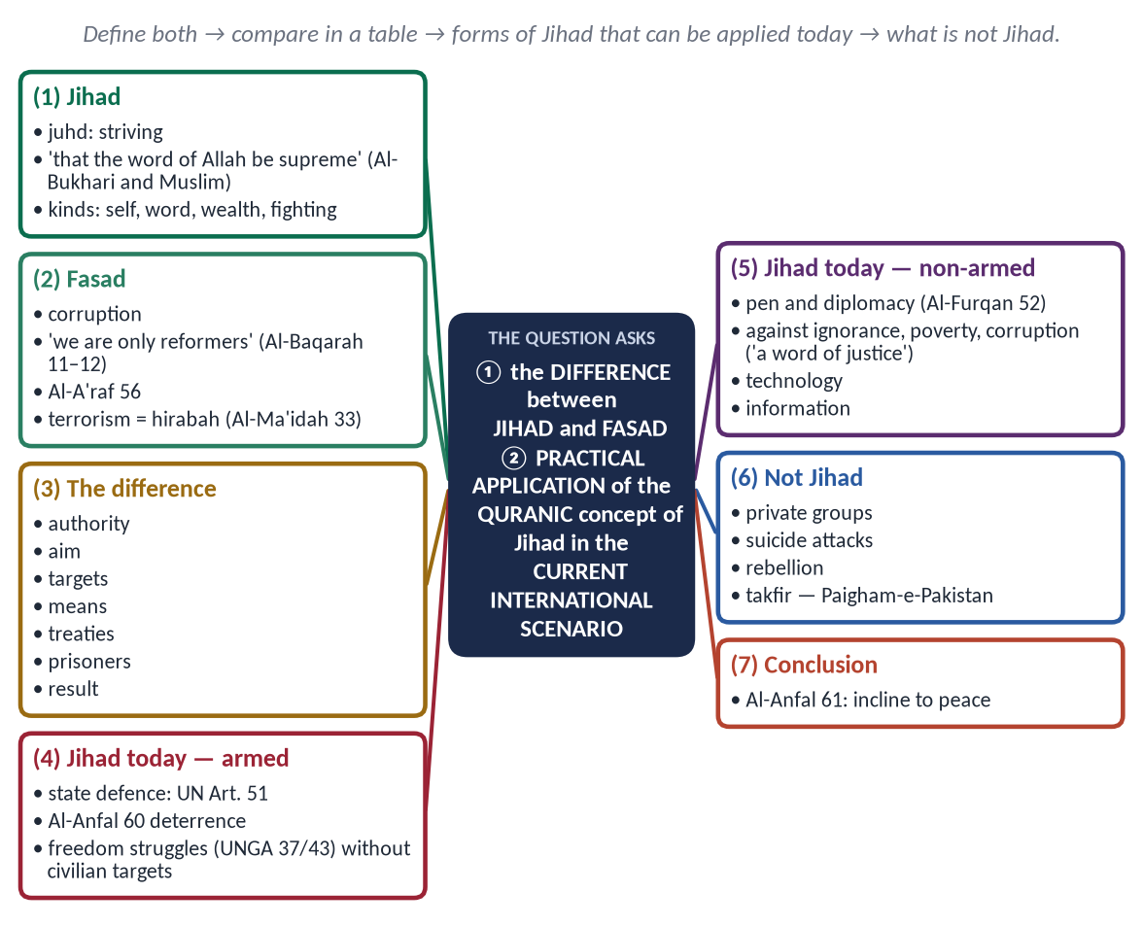
Figure 1 · The answer map: every branch is one numbered heading of the model answer below.

Decoding the question
- Limb 1 — define Jihad and Fasad and show the difference point by point.
- Limb 2 — 'possibilities of practical application … in current international scenario' — how the Quranic Jihad can be practised today, within international law, and what is excluded.
- 16 marks — keep it tight.

The model answer

(1) Introduction
Few Islamic words are as misunderstood as Jihad (جِهَاد). Terrorists misuse it for murder; critics equate it with holy war. The Quran uses it for striving in Allah's way in every field, and it clearly separates it from Fasad (فَسَاد) — corruption and mischief on earth.

(2) The meaning of Jihad
From juhd — effort — Jihad is striving to make the word of Allah supreme and to establish justice: against the self, with knowledge and word, with wealth, and — under the state and its conditions — with arms.
✦ HADITH
مَنْ قَاتَلَ لِتَكُونَ كَلِمَةُ اللَّهِ هِيَ الْعُلْيَا فَهُوَ فِي سَبِيلِ اللَّهِ
“Whoever fights so that the word of Allah is supreme is in the way of Allah.” (Al-Bukhari and Muslim)

✦ QURAN
﴿فَلَا تُطِعِ ٱلۡكَٰفِرِينَ وَجَٰهِدۡهُم بِهِۦ جِهَادٗا كَبِيرٗا﴾
“So do not obey the disbelievers, and strive against them with the Qur'an a great striving.” (Al-Furqan, Quran)
➜ 'Strive against them with it (the Quran) a great striving' — a Makkan command, before any fighting was allowed.

✦ QURAN
﴿وَجَٰهِدُواْ فِي ٱللَّهِ حَقَّ جِهَادِهِۦۚ …﴾
“And strive for Allah with the striving due to Him.” (Al-Hajj, Quran)
➜ Jihad is first a striving, in every field.

The levels of Jihad (Ibn al-Qayyim, Zad al-Ma'ad): against the self, against Shaytan, against disbelievers and hypocrites (by argument, wealth and — under the state — arms), and against oppression and wrongdoing. Armed struggle is only one level, and the last.

(3) The meaning of Fasad
Fasad is spoiling what Allah made sound — life, property, peace and society.
✦ QURAN
﴿وَإِذَا قِيلَ لَهُمۡ لَا تُفۡسِدُواْ فِي ٱلۡأَرۡضِ قَالُوٓاْ إِنَّمَا نَحۡنُ مُصۡلِحُونَ ۝ أَلَآ إِنَّهُمۡ هُمُ ٱلۡمُفۡسِدُونَ وَلَٰكِن لَّا يَشۡعُرُونَ﴾
“And when it is said to them, "Do not cause corruption on the earth," they say, "We are but reformers. Unquestionably, it is they who are the corrupters, but they perceive [it] not.” (Al-Baqarah, Quran)
➜ When told 'do not spread corruption', they say 'we are only reformers'. Indeed, it is they who are the corrupters.

✦ QURAN
﴿وَلَا تُفۡسِدُواْ فِي ٱلۡأَرۡضِ بَعۡدَ إِصۡلَٰحِهَا وَٱدۡعُوهُ خَوۡفٗا وَطَمَعًاۚ إِنَّ رَحۡمَتَ ٱللَّهِ قَرِيبٞ مِّنَ ٱلۡمُحۡسِنِينَ﴾
“And cause not corruption upon the earth after its reformation. And invoke Him in fear and aspiration. Indeed, the mercy of Allah is near to the doers of good.” (Al-A'raf, Quran)
➜ 'Do not cause corruption in the land after it has been set right.'

✦ QURAN
﴿إِنَّمَا جَزَـٰٓؤُاْ ٱلَّذِينَ يُحَارِبُونَ ٱللَّهَ وَرَسُولَهُۥ وَيَسۡعَوۡنَ فِي ٱلۡأَرۡضِ فَسَادًا …﴾
“The recompense of those who wage war against Allah and His Messenger and strive to spread corruption (fasad) in the land …” (Al-Ma'idah, Quran)
➜ The recompense of those who wage war against Allah and His Messenger and spread fasad in the land …

✦ QURAN
﴿ظَهَرَ ٱلۡفَسَادُ فِي ٱلۡبَرِّ وَٱلۡبَحۡرِ بِمَا كَسَبَتۡ أَيۡدِي ٱلنَّاسِ لِيُذِيقَهُم بَعۡضَ ٱلَّذِي عَمِلُواْ لَعَلَّهُمۡ يَرۡجِعُونَ﴾
“Corruption has appeared throughout the land and sea by [reason of] what the hands of people have earned so He may let them taste part of [the consequence of] what they have done that perhaps they will return [to righteousness].” (Ar-Rum, Quran)
➜ 'Corruption has appeared on land and sea because of what the hands of people have earned.'

Fasad in today's world: terrorism and suicide bombing; sectarian killing; corruption and theft of public wealth; drug and arms trafficking; hoarding and adulteration; environmental destruction.

(4) The difference between Jihad and Fasad
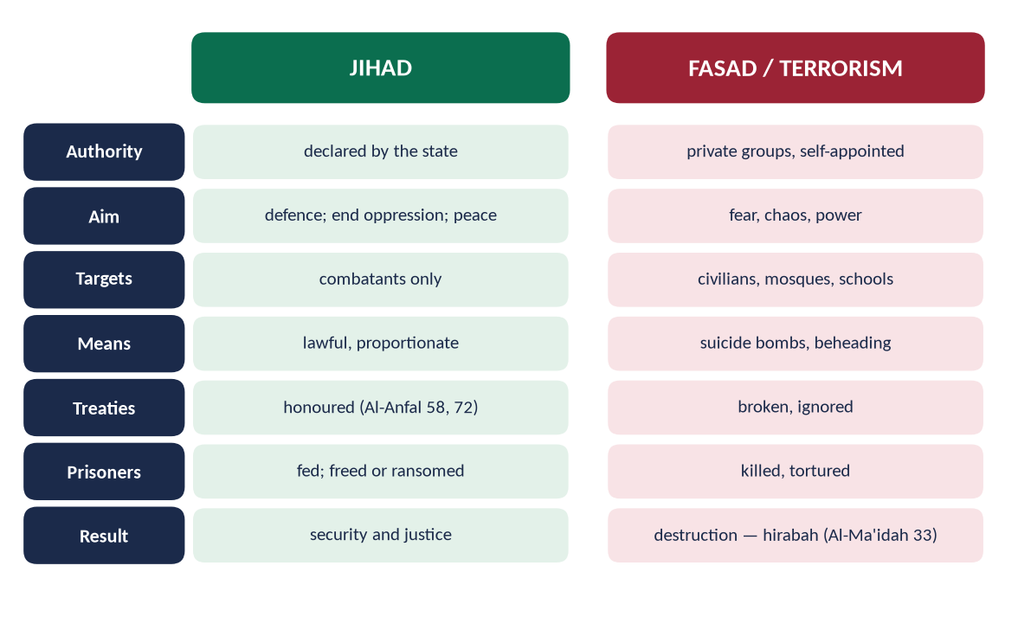
Figure 2 · Jihad and Fasad compared.
Point | Jihad | Fasad
Authority | The state | Self-appointed groups
Aim | Defence, justice, peace | Fear, chaos, power
Targets | Combatants only | Civilians, mosques, schools
Means | Lawful, proportionate | Suicide bombs, beheading
Treaties | Honoured (Al-Anfal 58) | Broken
Prisoners | Fed; freed or ransomed (Muhammad 4) | Killed
Result | Security and justice | Destruction

(5) The practical application of Jihad in the current international scenario

(i) Defensive Jihad by the state
✦ QURAN
﴿وَأَعِدُّواْ لَهُم مَّا ٱسۡتَطَعۡتُم مِّن قُوَّةٖ وَمِن رِّبَاطِ ٱلۡخَيۡلِ تُرۡهِبُونَ بِهِۦ عَدُوَّ ٱللَّهِ وَعَدُوَّكُمۡ …﴾
“Prepare against them whatever you are able of power and of steeds of war, by which you may deter the enemy of Allah and your enemy.” (Al-Anfal, Quran)
➜ Prepare whatever strength you can to deter the enemy.

Every state's right of self-defence is recognised by Article 51 of the UN Charter; Pakistan's armed forces and its deterrence are Jihad in this lawful sense.

(ii) Struggles against occupation
International law recognises the right of peoples under foreign occupation to self-determination (UNGA Resolution 37/43, 1982) — as in Kashmir and Palestine — but civilians may never be targeted.

(iii) Jihad of the pen, diplomacy and law
Advocacy at the UN, the ICJ and human-rights forums; scholarship and media that answer Islamophobia.

(iv) Jihad against ignorance, poverty and disease
Education, science, Zakat and health — the Ummah's greatest battles today.

(v) Jihad against corruption and tyranny
✦ HADITH
أَفْضَلُ الْجِهَادِ كَلِمَةُ عَدْلٍ عِنْدَ سُلْطَانٍ جَائِرٍ
“The best jihad is a word of justice before a tyrant ruler.” (Abu Dawud and Al-Tirmidhi)

(vi) Jihad against the self
✦ HADITH
الْمُجَاهِدُ مَنْ جَاهَدَ نَفْسَهُ
“The true mujahid is the one who strives against his own self.” (Al-Tirmidhi)

(viii) Jihad through service
A man asked the Prophet ﷺ for permission to join a campaign; he asked, 'Are your parents alive?' — 'Yes.' — 'Then strive in serving them' (Al-Bukhari and Muslim): فَفِيهِمَا فَجَاهِدْ. Service to parents, the poor and the sick is Jihad too.

(vii) Technological and economic Jihad
Self-reliance in defence, energy and technology — strength that makes war less likely.

(6) What is not Jihad
Attacks by private groups, suicide bombings, rebellion against Muslim states, and takfir to justify killing — all are fasad. Paigham-e-Pakistan (2018), signed by over 1,800 scholars of all schools, declared that only the state may declare jihad.
Pakistan's law agrees: Article 256 of the Constitution forbids private military organisations, and the Anti-Terrorism Act (1997) punishes violence meant to spread fear. The Islamic and the constitutional positions are the same — Jihad belongs to the state, within law.

(7) Conclusion
✦ QURAN
﴿وَإِن جَنَحُواْ لِلسَّلۡمِ فَٱجۡنَحۡ لَهَا وَتَوَكَّلۡ عَلَى ٱللَّهِۚ إِنَّهُۥ هُوَ ٱلسَّمِيعُ ٱلۡعَلِيمُ﴾
“And if they incline to peace, then incline to it [also] and rely upon Allah. Indeed, it is He who is the Hearing, the Knowing.” (Al-Anfal, Quran)
➜ 'If they incline to peace, incline to it and rely upon Allah.'

Jihad is lawful striving for justice and peace, bound by the state and by rules; Fasad is lawless destruction. In today's world, the Quranic Jihad is practised by lawful defence, by the pen and diplomacy, and above all by the struggle against ignorance, poverty and corruption.

Why this answer scores
- Both concepts defined with Quran and Hadith; the difference shown in a table.
- Seven practical forms of Jihad today, tied to international law (Art. 51; UNGA 37/43).
- A clear line on what is not Jihad, with Paigham-e-Pakistan.

Answer 2 · The Principles and Conditions of Jihad (CSS 2020)
THE QUESTION · CSS 2020 · Q5 · 20 marks
Discuss in detail the principles and terms & conditions for "Jihad" in the light of Quran and Sunnah.

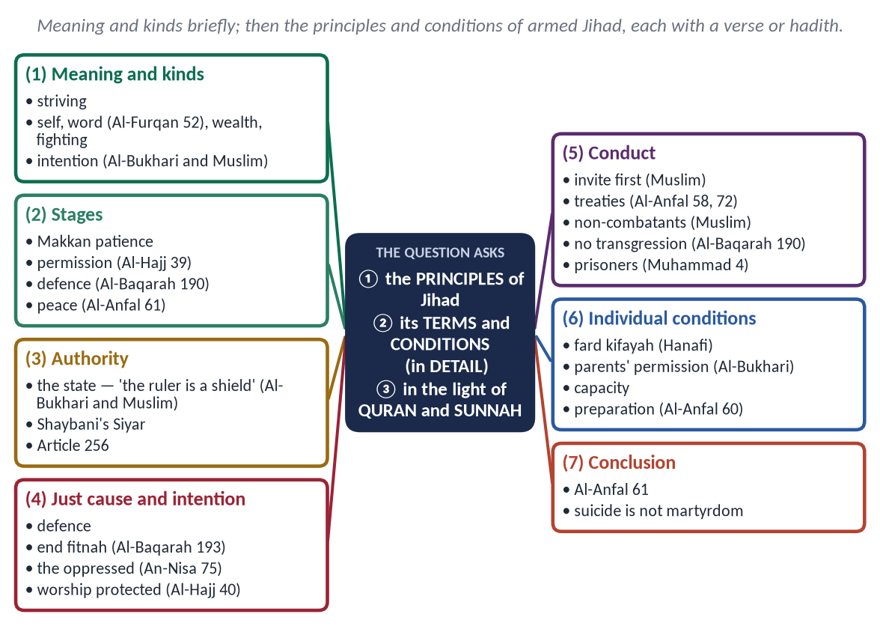
Figure 3 · The answer map: every branch is one numbered heading of the model answer below.

Decoding the question
- 'Principles' — the fundamental rules that govern Jihad.
- 'Terms and conditions' — when it becomes lawful, who may declare it, how it must be fought, and who must take part.
- 'In detail' and 'in the light of Quran and Sunnah' — each condition with evidence.

The model answer

(1) Introduction
Jihad (جِهَاد), from juhd (effort), is striving in the way of Allah. Armed struggle (qital) is one form of it, surrounded by strict principles that make it a just, limited and lawful act — the opposite of terrorism.

(2) The kinds of Jihad
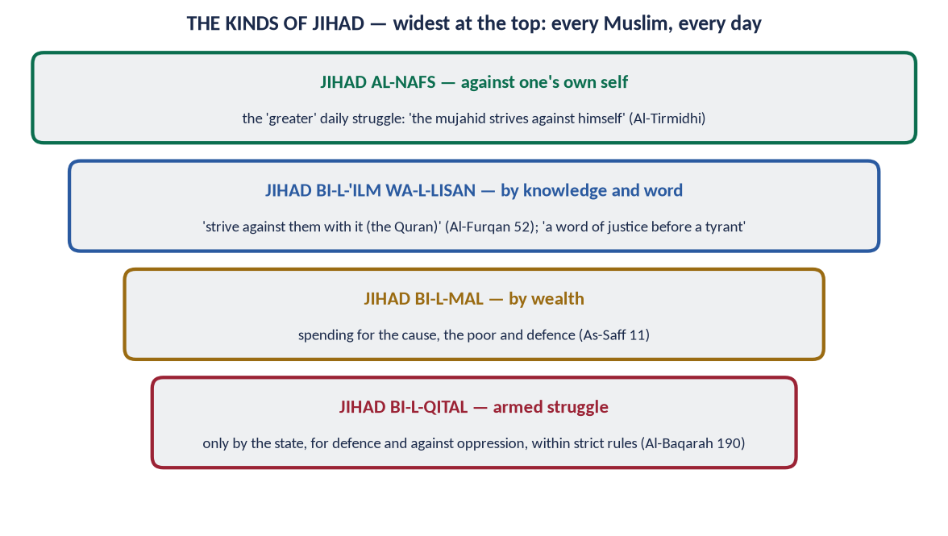
Figure 4 · The kinds of Jihad.
- Against the self — 'the true mujahid strives against his own self' (Al-Tirmidhi).
- By knowledge and word — 'strive against them with it (the Quran)' (Al-Furqan 52).
- By wealth — As-Saff 11.
- By fighting — under the conditions below.

(3) The stages of the command
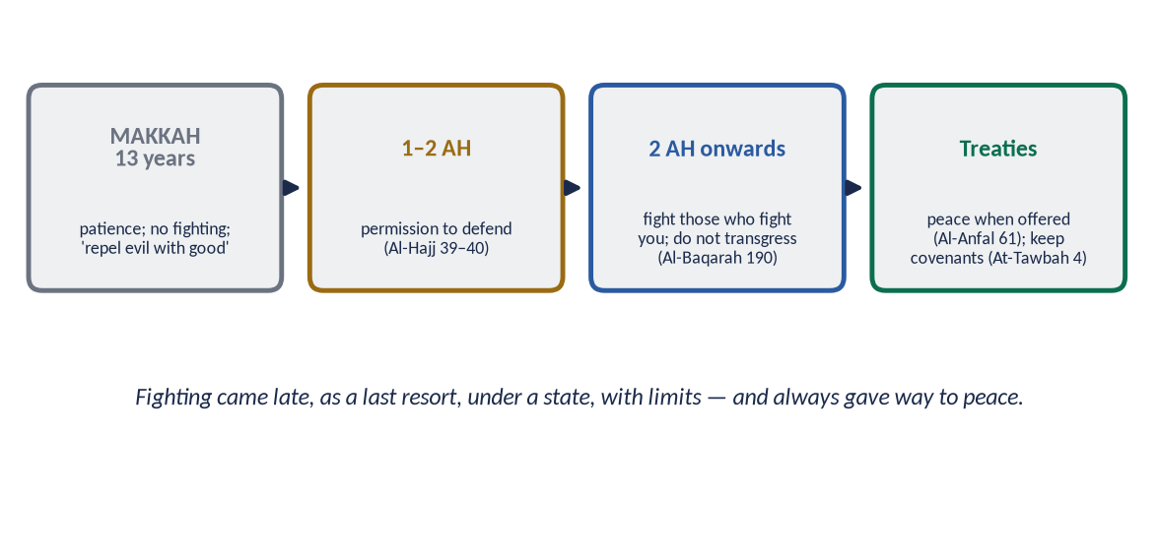
Figure 5 · Patience, permission, defence, treaties.
Thirteen Makkan years of patience; permission after persecution (Al-Hajj 39); defence without transgression (Al-Baqarah 190); peace whenever offered (Al-Anfal 61).
✦ QURAN
﴿كُتِبَ عَلَيۡكُمُ ٱلۡقِتَالُ وَهُوَ كُرۡهٞ لَّكُمۡۖ …﴾
“Fighting has been prescribed for you, though it is hateful to you.” (Al-Baqarah, Quran)
➜ 'Fighting has been prescribed for you, though it is hateful to you' — never loved for itself.

(4) The principles and conditions of armed Jihad

(i) Authority — only the state
✦ HADITH
إِنَّمَا الْإِمَامُ جُنَّةٌ يُقَاتَلُ مِنْ وَرَائِهِ وَيُتَّقَى بِهِ
“The ruler is a shield: one fights behind him and is protected by him.” (Al-Bukhari and Muslim)

The Hanafi jurist Imam Muhammad al-Shaybani (d. 805), in Kitab al-Siyar al-Kabir, placed the declaration and conduct of war with the ruler. Pakistan's Article 256 forbids private military organisations.

(ii) A just cause
✦ QURAN
﴿أُذِنَ لِلَّذِينَ يُقَٰتَلُونَ بِأَنَّهُمۡ ظُلِمُواْۚ وَإِنَّ ٱللَّهَ عَلَىٰ نَصۡرِهِمۡ لَقَدِيرٌ﴾
“Permission [to fight] has been given to those who are being fought, because they were wronged. And indeed, Allah is competent to give them victory.” (Al-Hajj, Quran)
➜ Permission is given to those who are fought against, because they have been wronged.

✦ QURAN
﴿وَقَٰتِلُوهُمۡ حَتَّىٰ لَا تَكُونَ فِتۡنَةٞ وَيَكُونَ ٱلدِّينُ لِلَّهِۖ فَإِنِ ٱنتَهَوۡاْ فَلَا عُدۡوَٰنَ إِلَّا عَلَى ٱلظَّـٰلِمِينَ﴾
“Fight them until there is no [more] fitnah and [until] worship is [acknowledged to be] for Allah. But if they cease, then there is to be no aggression except against the oppressors.” (Al-Baqarah, Quran)
➜ Fight until there is no more fitnah (persecution).

✦ QURAN
﴿وَمَا لَكُمۡ لَا تُقَٰتِلُونَ فِي سَبِيلِ ٱللَّهِ وَٱلۡمُسۡتَضۡعَفِينَ مِنَ ٱلرِّجَالِ وَٱلنِّسَآءِ وَٱلۡوِلۡدَٰنِ …﴾
“What is wrong with you that you do not fight in the cause of Allah and for the oppressed among men, women and children?” (An-Nisa, Quran)
➜ Fight for the oppressed men, women and children.

Not for land, wealth, revenge or forced conversion — 'no compulsion in religion' (Al-Baqarah 256).

(iii) The right intention
'Whoever fights so that the word of Allah is supreme is in the way of Allah' (Al-Bukhari and Muslim) — not for booty, fame or pride.

(iv) Invitation and warning first
The Prophet ﷺ instructed his commanders to offer Islam, a treaty or peace before fighting (Muslim, the hadith of Buraydah).

(v) Honouring treaties
✦ QURAN
﴿وَإِمَّا تَخَافَنَّ مِن قَوۡمٍ خِيَانَةٗ فَٱنۢبِذۡ إِلَيۡهِمۡ عَلَىٰ سَوَآءٍۚ إِنَّ ٱللَّهَ لَا يُحِبُّ ٱلۡخَآئِنِينَ﴾
“If you [have reason to] fear from a people betrayal, throw [their treaty] back to them, [putting you] on equal terms. Indeed, Allah does not like traitors.” (Al-Anfal, Quran)
➜ If you fear treachery, openly declare the treaty ended — no surprise attack in peace.

✦ QURAN
﴿… وَإِنِ ٱسۡتَنصَرُوكُمۡ فِي ٱلدِّينِ فَعَلَيۡكُمُ ٱلنَّصۡرُ …﴾
“And if they seek your help in the matter of religion, then it is your duty to help them.” (Al-Anfal, Quran)
➜ Help your fellow believers except against a people with whom you have a treaty.

(vi) Protection of non-combatants
✦ HADITH
اغْزُوا بِاسْمِ اللَّهِ ... وَلَا تَغُلُّوا، وَلَا تَغْدِرُوا، وَلَا تَمْثُلُوا، وَلَا تَقْتُلُوا وَلِيدًا
“Fight in the name of Allah … do not steal, do not betray, do not mutilate, do not kill a child.” (Muslim)

Women, children, the old and monks are protected; fruit trees and towns spared (Abu Bakr's orders, Muwatta).

(vii) Proportionality
✦ QURAN
﴿وَقَٰتِلُواْ فِي سَبِيلِ ٱللَّهِ ٱلَّذِينَ يُقَٰتِلُونَكُمۡ وَلَا تَعۡتَدُوٓاْۚ إِنَّ ٱللَّهَ لَا يُحِبُّ ٱلۡمُعۡتَدِينَ﴾
“Fight in the way of Allah those who fight you but do not transgress. Indeed. Allah does not like transgressors.” (Al-Baqarah, Quran)
➜ Fight those who fight you, but do not transgress; Allah does not love transgressors.

(viii) Humane treatment of prisoners
✦ QURAN
﴿… فَإِمَّا مَنَّۢا بَعۡدُ وَإِمَّا فِدَآءً حَتَّىٰ تَضَعَ ٱلۡحَرۡبُ أَوۡزَارَهَاۚ …﴾
“… then either free them as a favour or for ransom, until the war lays down its burdens.” (Muhammad, Quran)
➜ … either free them as a favour or for ransom.

✦ QURAN
﴿وَيُطۡعِمُونَ ٱلطَّعَامَ عَلَىٰ حُبِّهِۦ مِسۡكِينٗا وَيَتِيمٗا وَأَسِيرًا﴾
“And they give food in spite of love for it to the needy, the orphan, and the captive.” (Al-Insan, Quran)
➜ They give food … to the captive.

(ix) Peace when offered
✦ QURAN
﴿وَإِن جَنَحُواْ لِلسَّلۡمِ فَٱجۡنَحۡ لَهَا وَتَوَكَّلۡ عَلَى ٱللَّهِۚ إِنَّهُۥ هُوَ ٱلسَّمِيعُ ٱلۡعَلِيمُ﴾
“And if they incline to peace, then incline to it [also] and rely upon Allah. Indeed, it is He who is the Hearing, the Knowing.” (Al-Anfal, Quran)
➜ 'If they incline to peace, incline to it.'

(x) Individual conditions
- Fard kifayah normally; fard 'ayn only on a general mobilisation by the state (Hanafi).
- Parents' permission for voluntary service — 'Then strive in serving them' (Al-Bukhari).
- Capacity — adult, sane, able.
- Preparation — 'prepare whatever strength you can' (Al-Anfal 60).
Principle | Evidence
State authority | 'The ruler is a shield'; Shaybani; Art. 256
Just cause | Al-Hajj 39; Al-Baqarah 193; An-Nisa 75
Intention | 'That the word of Allah be supreme'
Invitation first | Hadith of Buraydah
Treaties | Al-Anfal 58, 72
Non-combatants | Muslim; Muwatta
No transgression | Al-Baqarah 190
Prisoners | Muhammad 4; Al-Insan 8
Peace | Al-Anfal 61

(5) Martyrdom and suicide
✦ QURAN
﴿وَلَا تَحۡسَبَنَّ ٱلَّذِينَ قُتِلُواْ فِي سَبِيلِ ٱللَّهِ أَمۡوَٰتَۢاۚ بَلۡ أَحۡيَآءٌ عِندَ رَبِّهِمۡ يُرۡزَقُونَ﴾
“And never think of those who have been killed in the cause of Allah as dead. Rather, they are alive with their Lord, receiving provision.” (Aal-e-Imran, Quran)
➜ Those killed in the way of Allah are alive with their Lord.

Martyrdom belongs to one who falls in a lawful struggle, with a pure intention, by the enemy's hand; a suicide bomber who kills innocents commits suicide and murder — he is no martyr.

(6) Conclusion
✦ SCHOLARLY VIEW
Paigham-e-Pakistan (2018) · Consensus of 1,800+ scholars
Only the state may declare jihad; suicide attacks are haram; armed rebellion against the state is baghawat.
➜ The Pakistani consensus on the conditions of Jihad.

Jihad in the Quran and Sunnah is a disciplined institution: declared by the state, for a just cause, with a pure intention, after warning, within treaties, sparing non-combatants and prisoners, and ending in peace. These conditions are exactly what separate it from terrorism.

Why this answer scores
- Ten principles and conditions, each with Quran or Hadith — 'in detail'.
- Hanafi authority (Shaybani) and Pakistani law (Article 256).
- A summary table and the martyrdom–suicide distinction.

Answer 3 · Is Extremism a Challenge to Islam? — In the Context of the Ummah's Challenges (CSS 2019)
THE QUESTION · CSS 2019 · Q7 · 20 marks
Is extremism a challenge to Islam? Discuss in the context of contemporary challenges faced by Muslim Ummah.

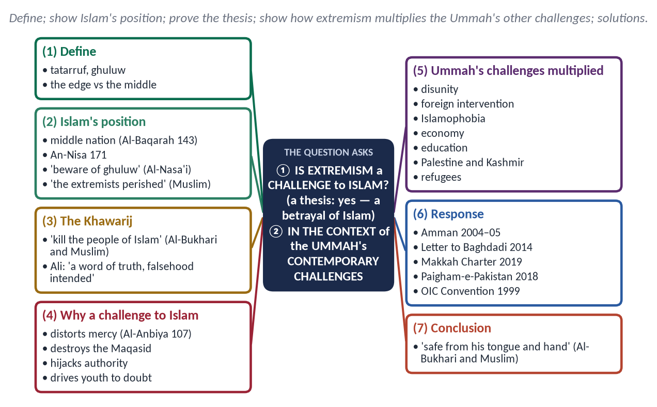
Figure 6 · The answer map: every branch is one numbered heading of the model answer below.

Decoding the question
- 'Is extremism a challenge to Islam?' — a thesis question: answer yes, and explain that extremism is a betrayal of Islam, not an expression of it.
- 'In the context of contemporary challenges faced by the Muslim Ummah' — show how extremism relates to and worsens the Ummah's other challenges.

The model answer

(1) Introduction
The Muslim Ummah faces disunity, poverty, occupation, Islamophobia and cultural pressure. Among these, extremism is unique: it wears the dress of Islam while attacking Islam's own teachings. It is therefore a challenge to Islam itself — to its message, its image and its people.

(2) What extremism is
Tatarruf (تَطَرُّف) — standing at the edge; ghuluw (غُلُوّ) — exceeding the limits. Extremism is going beyond the limits Allah set, in belief, word and action — making religion harsh, declaring others disbelievers, and using violence.
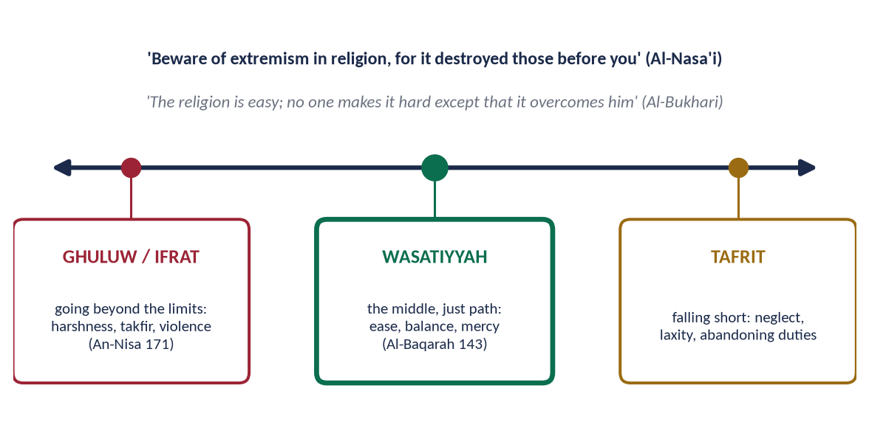
Figure 7 · Ghuluw, wasatiyyah and tafrit.
Firmness is not extremism. A Muslim who prays, fasts and keeps a beard or hijab is practising, not extreme. Extremism begins when one imposes one's view by force, excludes others from Islam, and permits violence. It appears at four levels:
- In belief — takfir of Muslims and rulers.
- In worship — burdens Allah did not impose; the Prophet ﷺ corrected the three men who vowed never to sleep, never to break fast and never to marry: 'Whoever turns away from my Sunnah is not of me' (Al-Bukhari).
- In conduct — harshness, contempt and hate speech.
- In politics — rebellion and terrorism in the name of religion.

(3) Islam's position — the middle path
✦ QURAN
﴿وَكَذَٰلِكَ جَعَلۡنَٰكُمۡ أُمَّةٗ وَسَطٗا لِّتَكُونُواْ شُهَدَآءَ عَلَى ٱلنَّاسِ وَيَكُونَ ٱلرَّسُولُ عَلَيۡكُمۡ شَهِيدٗاۗ …﴾
“And thus We have made you a middle (just) nation, that you may be witnesses over mankind and the Messenger a witness over you.” (Al-Baqarah, Quran)
➜ 'We have made you a middle nation.'

✦ QURAN
﴿… لَا تَغۡلُواْ فِي دِينِكُمۡ وَلَا تَقُولُواْ عَلَى ٱللَّهِ إِلَّا ٱلۡحَقَّۚ …﴾
“O People of the Scripture, do not go to extremes in your religion, and do not say about Allah except the truth.” (An-Nisa, Quran)
➜ 'Do not go to extremes in your religion.'

✦ HADITH
إِيَّاكُمْ وَالْغُلُوَّ فِي الدِّينِ، فَإِنَّمَا أَهْلَكَ مَنْ كَانَ قَبْلَكُمُ الْغُلُوُّ فِي الدِّينِ
“Beware of extremism in religion, for those before you were destroyed only by extremism in religion.” (Al-Nasa'i and Ibn Majah)

✦ HADITH
هَلَكَ الْمُتَنَطِّعُونَ
“The extremists perished.” (Muslim)
➜ Said three times.

(4) The first extremists — the Khawarij
✦ HADITH
يَقْتُلُونَ أَهْلَ الْإِسْلَامِ وَيَدَعُونَ أَهْلَ الْأَوْثَانِ
“They will kill the people of Islam and leave the idol-worshippers alone.” (Al-Bukhari and Muslim)

They emerged after Siffin (657) with the slogan 'judgement is only for Allah'; Ali (RA) called it 'a word of truth by which falsehood is intended' (Muslim), sent Ibn Abbas to reason with them, and fought them only when they killed Muslims (Nahrawan, 658). Modern extremist groups repeat their features: takfir, literalism and violence against Muslims.
✦ HADITH
يَقْرَءُونَ الْقُرْآنَ لَا يُجَاوِزُ حَنَاجِرَهُمْ
“They recite the Quran, but it does not go beyond their throats.” (Al-Bukhari and Muslim)
➜ Much outward piety, no understanding — the mark of every extremist movement since.

(5) Why extremism is a challenge to Islam
- (a) It distorts the message — 'a mercy to all the worlds' (Al-Anbiya 107) becomes, in the world's eyes, a religion of terror.
- (b) It destroys the Maqasid — life, faith, intellect, lineage and property — the very aims of the Shari'ah.
- (c) It hijacks religious authority — unqualified men issue fatwas of death.
- (d) It drives young Muslims away — disgust at violence in God's name breeds doubt.
- (e) It kills Muslims most — the majority of terrorism's victims worldwide are Muslims.
✦ QURAN
﴿… مَن قَتَلَ نَفۡسَۢا بِغَيۡرِ نَفۡسٍ أَوۡ فَسَادٖ فِي ٱلۡأَرۡضِ فَكَأَنَّمَا قَتَلَ ٱلنَّاسَ جَمِيعٗا وَمَنۡ أَحۡيَاهَا فَكَأَنَّمَآ أَحۡيَا ٱلنَّاسَ جَمِيعٗاۚ …﴾
“Whoever kills a soul — unless for a soul or for corruption in the land — it is as if he had slain mankind entirely; and whoever saves one, it is as if he had saved mankind entirely.” (Al-Ma'idah, Quran)
➜ Killing one innocent soul is like killing all mankind.

Recent examples: ISIS (2014–2019) declared a 'caliphate' in Iraq and Syria, killed mostly Muslims, destroyed mosques and shrines and drove millions from their homes; in Pakistan, the TTP attacked schools, mosques and markets. Both claimed Islam; both were rejected by the scholars of the Ummah.

(6) How extremism multiplies the Ummah's other challenges
Challenge | How extremism worsens it
Disunity | Takfir and sectarian war split the Ummah
Foreign intervention | Terror gives a pretext (Afghanistan 2001, Iraq 2003)
Islamophobia | Each attack feeds anti-Muslim hate
Economic backwardness | Investment and tourism flee; budgets go to security
Education | Schools destroyed; girls kept out (Swat 2008–09)
Palestine and Kashmir | Terror weakens the moral case of just causes
Refugees | Wars fuelled by extremists displaced millions (Syria, Iraq)

Pakistan's own experience: over 80,000 killed and over 126 billion dollars lost (2001–2018); no international cricket for a decade after the attack on the Sri Lankan team (Lahore, 2009).

(7) The Ummah's response
- Scholarly consensus: the Amman Message (2004–05); the Letter to Baghdadi (2014); the Charter of Makkah (2019, 1,200+ scholars); Paigham-e-Pakistan (2018).
- Institutions: the OIC Convention on Combating International Terrorism (1999); the IMCTC (2015).
- Still needed: an end to proxy wars; justice for Palestine and Kashmir through law; education and jobs for youth.
What the Ummah must still do:
- Education — teaching the Quran with context and the jurists' principles, so that half-knowledge cannot be exploited.
- Justice and good governance — removing the grievances extremists exploit.
- Dialogue — engaging the young, as Ibn Abbas engaged the Khawarij.
- Freedom of belief — 'There is no compulsion in religion' (Al-Baqarah 256) forbids forcing faith on anyone.
Pakistan's contribution — the sacrifices of its soldiers, police and citizens; the National Action Plan (2014); and Paigham-e-Pakistan, which other Muslim countries have studied as a model.
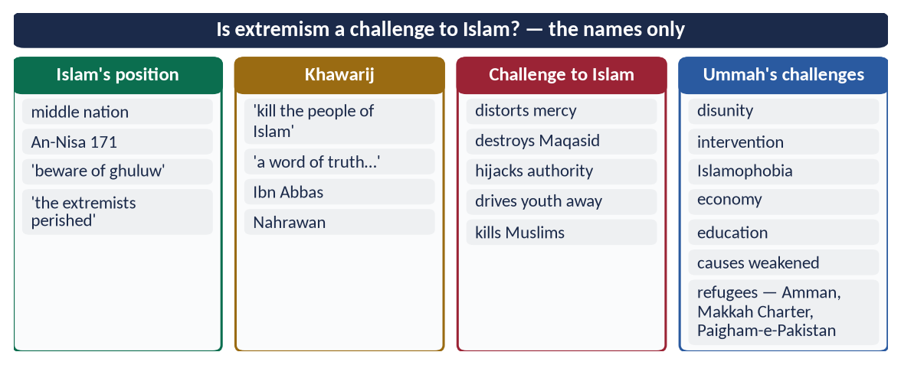
Figure 8 · At a glance — is extremism a challenge to Islam? — the names only. The detail is in the sections above.

(8) Conclusion
✦ HADITH
الْمُسْلِمُ مَنْ سَلِمَ الْمُسْلِمُونَ مِنْ لِسَانِهِ وَيَدِهِ
“The Muslim is the one from whose tongue and hand the Muslims are safe.” (Al-Bukhari and Muslim)

Extremism is indeed a challenge to Islam — the gravest from within. It betrays the middle path, destroys the aims of the Shari'ah, and multiplies every other challenge the Ummah faces. The answer is the Islam of the Quran and Sunnah itself: moderation, knowledge, justice and unity.

Why this answer scores
- A clear thesis (yes — a betrayal) proved from Quran, Sunnah and history.
- The Ummah context is shown in a table — extremism as a multiplier of other challenges.
- The response includes scholarly and institutional evidence.

Answer 4 · Reasons of Extremism in Pakistan and Solutions in the Light of Islam (CSS 2017)
THE QUESTION · CSS 2017 · Q7 · 20 marks
Enumerate the reasons of extremism in Pakistan and suggest solutions to eradicate it in the light of Islamic teachings.

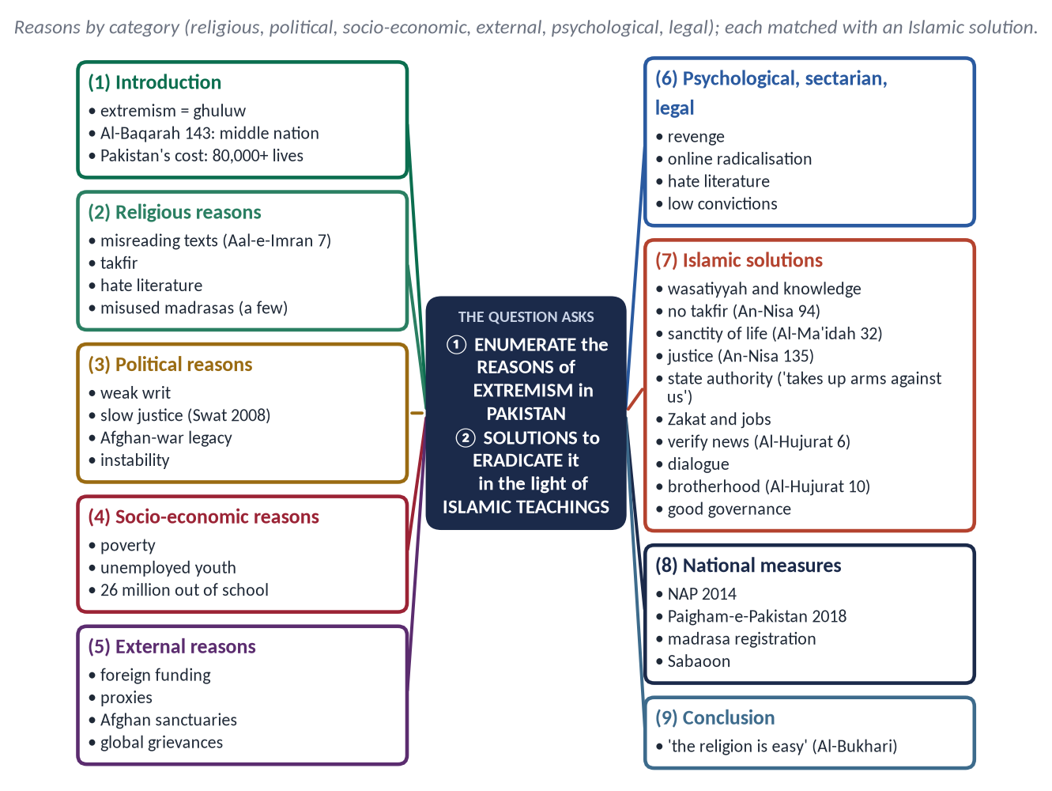
Figure 9 · The answer map: every branch is one numbered heading of the model answer below.

Decoding the question
- 'Enumerate the reasons' — a list, grouped and explained, specific to Pakistan.
- 'Solutions … in the light of Islamic teachings' — each solution with a verse or hadith, plus practical steps.

The model answer

(1) Introduction
Extremism — ghuluw (غُلُوّ), going beyond Allah's limits — has cost Pakistan over 80,000 lives and over 126 billion dollars (2001–2018). It is contrary to the Quran's middle path:
✦ QURAN
﴿وَكَذَٰلِكَ جَعَلۡنَٰكُمۡ أُمَّةٗ وَسَطٗا لِّتَكُونُواْ شُهَدَآءَ عَلَى ٱلنَّاسِ وَيَكُونَ ٱلرَّسُولُ عَلَيۡكُمۡ شَهِيدٗاۗ …﴾
“And thus We have made you a middle (just) nation, that you may be witnesses over mankind and the Messenger a witness over you.” (Al-Baqarah, Quran)
➜ 'We have made you a middle nation.'

(2) The reasons of extremism in Pakistan
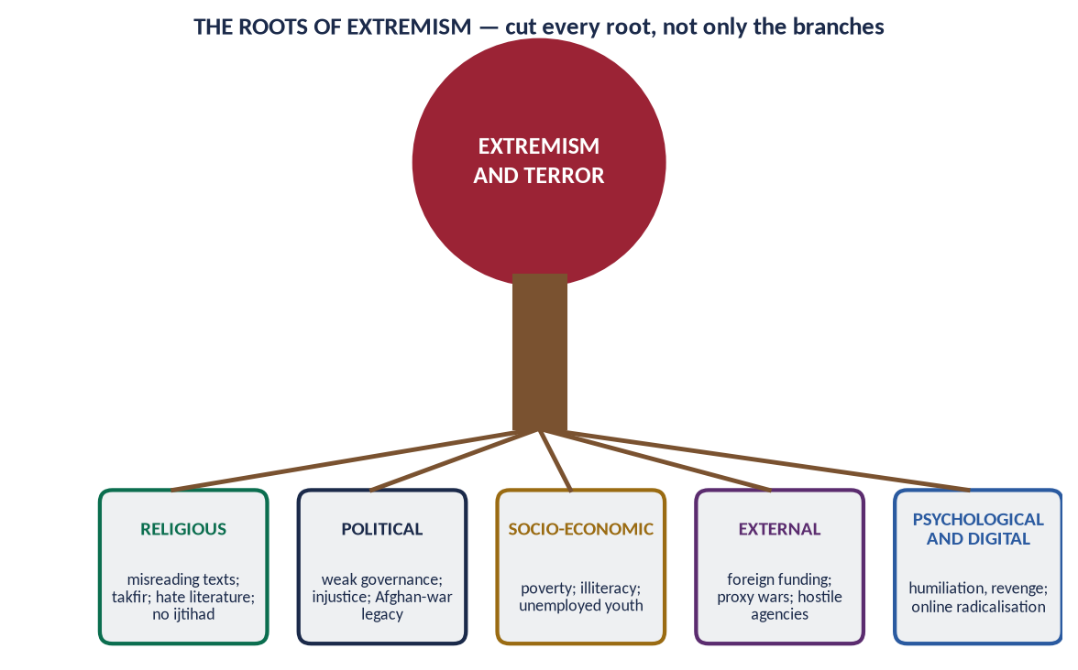
Figure 10 · The roots of extremism.

(i) Religious and ideological
- Misinterpretation of verses of war out of context; ignorance of the jurists' conditions.
✦ QURAN
﴿… فَأَمَّا ٱلَّذِينَ فِي قُلُوبِهِمۡ زَيۡغٞ فَيَتَّبِعُونَ مَا تَشَٰبَهَ مِنۡهُ ٱبۡتِغَآءَ ٱلۡفِتۡنَةِ وَٱبۡتِغَآءَ تَأۡوِيلِهِۦۖ …﴾
“As for those in whose hearts is deviation, they follow what is ambiguous in it, seeking discord and seeking an interpretation of it.” (Aal-e-Imran, Quran)
➜ Those in whose hearts is deviation follow what is ambiguous, seeking fitnah.

- Takfir of the state, the army and other Muslims.
- Hate literature and sermons; misuse of loudspeakers.
- Misuse of a small number of madrasas by militant groups.

(ii) Political
- The legacy of the Afghan war (1979–89): weapons, refugees, armed groups.
- Weak writ of the state in former FATA and parts of Balochistan.
- Slow and costly justice — in Swat (2008) militants won support by promising 'quick justice'.
- Political instability and polarisation.

(iii) Socio-economic
- Poverty and unemployment among a young population.
- Illiteracy — about 26 million children out of school.
- Social injustice — the powerful above the law.

(iv) External
- Foreign funding of sectarian and militant groups; proxy conflicts; sanctuaries across the Afghan border.
- Global grievances — Palestine, Kashmir, drone strikes — exploited in propaganda.

(v) Psychological and digital
- Revenge for relatives killed; humiliation and identity crisis.
- Online radicalisation — videos, encrypted chats.

(vi) Sectarian
Hate literature and target killings between schools, often funded from outside; weak action against hate speech.

(vii) Legal and administrative
Low conviction rates, weak witness protection, terror financing (FATF grey list, 2018–2022).

(3) The solutions in the light of Islamic teachings

(i) Wasatiyyah through true knowledge
✦ HADITH
إِنَّ الدِّينَ يُسْرٌ، وَلَنْ يُشَادَّ الدِّينَ أَحَدٌ إِلَّا غَلَبَهُ
“The religion is easy; no one makes it hard except that it overcomes him.” (Al-Bukhari)

Teach the Quran with its context and the jurists' principles; the Seerah of mercy in every school and madrasa.

(ii) No takfir
✦ QURAN
﴿… إِذَا ضَرَبۡتُمۡ فِي سَبِيلِ ٱللَّهِ فَتَبَيَّنُواْ وَلَا تَقُولُواْ لِمَنۡ أَلۡقَىٰٓ إِلَيۡكُمُ ٱلسَّلَٰمَ لَسۡتَ مُؤۡمِنٗا …﴾
“O you who believe, when you go forth in the cause of Allah, verify, and do not say to one who offers you peace, 'You are not a believer.'” (An-Nisa, Quran)
➜ Do not say to one who offers you peace, 'You are not a believer.'

✦ HADITH
إِذَا قَالَ الرَّجُلُ لِأَخِيهِ يَا كَافِرُ، فَقَدْ بَاءَ بِهِ أَحَدُهُمَا
“If a man calls his brother 'disbeliever', it returns to one of them.” (Al-Bukhari)

(iii) The sanctity of life — no suicide attacks
✦ QURAN
﴿… مَن قَتَلَ نَفۡسَۢا بِغَيۡرِ نَفۡسٍ أَوۡ فَسَادٖ فِي ٱلۡأَرۡضِ فَكَأَنَّمَا قَتَلَ ٱلنَّاسَ جَمِيعٗا وَمَنۡ أَحۡيَاهَا فَكَأَنَّمَآ أَحۡيَا ٱلنَّاسَ جَمِيعٗاۚ …﴾
“Whoever kills a soul — unless for a soul or for corruption in the land — it is as if he had slain mankind entirely; and whoever saves one, it is as if he had saved mankind entirely.” (Al-Ma'idah, Quran)
➜ Killing one innocent soul is like killing all mankind.

✦ QURAN
﴿… لَا تَأۡكُلُوٓاْ أَمۡوَٰلَكُم بَيۡنَكُم بِٱلۡبَٰطِلِ إِلَّآ أَن تَكُونَ تِجَٰرَةً عَن تَرَاضٖ مِّنكُمۡۚ …﴾
“Do not consume one another's wealth unjustly, but only in lawful trade by mutual consent.” (An-Nisa, Quran)
➜ 'Do not kill yourselves.'

(iv) Authority of the state — no private armies
✦ HADITH
مَنْ حَمَلَ عَلَيْنَا السِّلَاحَ فَلَيْسَ مِنَّا
“Whoever takes up arms against us is not of us.” (Al-Bukhari and Muslim)

Article 256 of the Constitution forbids private military organisations; Paigham-e-Pakistan (2018): only the state may declare jihad.

(v) Justice
✦ QURAN
﴿يَـٰٓأَيُّهَا ٱلَّذِينَ ءَامَنُواْ كُونُواْ قَوَّـٰمِينَ بِٱلۡقِسۡطِ شُهَدَآءَ لِلَّهِ وَلَوۡ عَلَىٰٓ أَنفُسِكُمۡ أَوِ ٱلۡوَٰلِدَيۡنِ وَٱلۡأَقۡرَبِينَۚ …﴾
“O you who believe, stand firmly for justice, as witnesses for Allah, even if it be against yourselves, your parents or your relatives.” (An-Nisa, Quran)
➜ Stand firm for justice, even against yourselves.

Quick, cheap justice removes the militants' main recruiting promise.

(vi) Economic justice
✦ QURAN
﴿… كَيۡ لَا يَكُونَ دُولَةَۢ بَيۡنَ ٱلۡأَغۡنِيَآءِ مِنكُمۡۚ …﴾
“… so that it does not circulate only among the rich among you.” (Al-Hashr, Quran)
➜ So that wealth does not circulate only among the rich.

Zakat, jobs and skills for the young in the most affected districts.

(vii) Truthful information
✦ QURAN
﴿يَـٰٓأَيُّهَا ٱلَّذِينَ ءَامَنُوٓاْ إِن جَآءَكُمۡ فَاسِقُۢ بِنَبَإٖ فَتَبَيَّنُوٓاْ أَن تُصِيبُواْ قَوۡمَۢا بِجَهَٰلَةٖ فَتُصۡبِحُواْ عَلَىٰ مَا فَعَلۡتُمۡ نَٰدِمِينَ﴾
“O you who have believed, if there comes to you a disobedient one with information, investigate, lest you harm a people out of ignorance and become, over what you have done, regretful.” (Al-Hujurat, Quran)
➜ If a sinful person brings news, verify it.

Counter-narratives online; action against hate content (PECA 2016).

(viii) Dialogue with the misled
As Ali (RA) sent Ibn Abbas to reason with the Khawarij, scholars should engage those at risk; the door of repentance stays open (Al-Ma'idah 34) — as at Sabaoon in Swat.

(ix) Brotherhood and unity
✦ QURAN
﴿إِنَّمَا ٱلۡمُؤۡمِنُونَ إِخۡوَةٞ فَأَصۡلِحُواْ بَيۡنَ أَخَوَيۡكُمۡۚ وَٱتَّقُواْ ٱللَّهَ لَعَلَّكُمۡ تُرۡحَمُونَ﴾
“The believers are but brothers, so make settlement between your brothers. And fear Allah that you may receive mercy.” (Al-Hujurat, Quran)
➜ The believers are but brothers, so make peace between your brothers.

✦ HADITH
مَثَلُ الْمُؤْمِنِينَ فِي تَوَادِّهِمْ وَتَرَاحُمِهِمْ وَتَعَاطُفِهِمْ مَثَلُ الْجَسَدِ
“The believers in their love, mercy and compassion are like one body.” (Al-Bukhari and Muslim)
➜ Inter-sect councils, joint Friday themes and district peace committees make this real.

(x) Good governance and the reach of the state
✦ HADITH
كُلُّكُمْ رَاعٍ وَكُلُّكُمْ مَسْئُولٌ عَنْ رَعِيَّتِهِ
“Each of you is a shepherd and responsible for his flock.” (Al-Bukhari and Muslim)
➜ Schools, courts, police and jobs in every district — the FATA merger (2018) extended the Constitution to the tribal areas.

(4) The national measures
- National Action Plan (24 December 2014) — 20 points: against militias, hate speech, terror finance; madrasa regulation; criminal-justice reform.
- Operations — Rah-e-Rast (2009), Zarb-e-Azb (2014), Radd-ul-Fasaad (2017).
- Paigham-e-Pakistan — the ulema's consensus.
- Madrasa registration and modern subjects; FATA merger (2018).
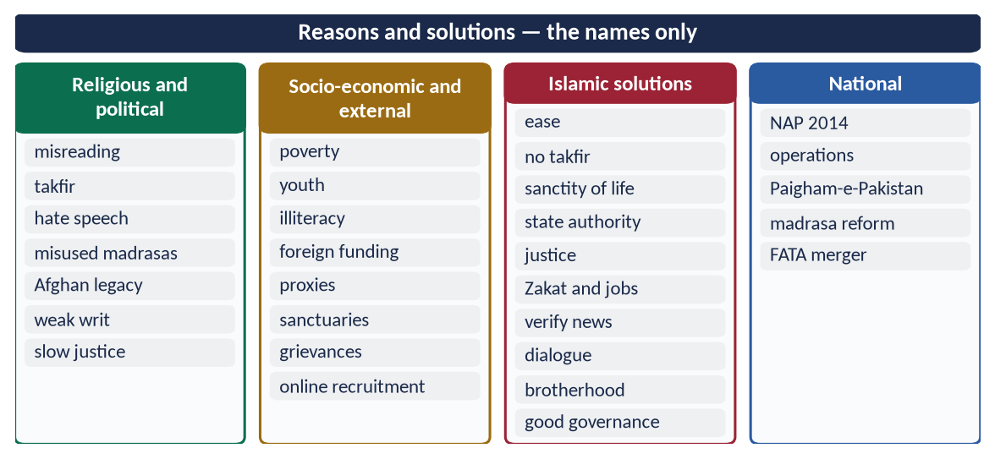
Figure 11 · At a glance — reasons and solutions — the names only. The detail is in the sections above.

(5) Conclusion
✦ HADITH
يَسِّرُوا وَلَا تُعَسِّرُوا، وَبَشِّرُوا وَلَا تُنَفِّرُوا
“Make things easy, not hard; give good news, do not drive people away.” (Al-Bukhari and Muslim)

The reasons of extremism in Pakistan are religious, political, economic, external and psychological. Its cure lies in the Islam of the Quran and Sunnah — ease, knowledge, sanctity of life, justice and the authority of the state — joined to firm national action.

Why this answer scores
- Reasons enumerated in six clear groups, specific to Pakistan.
- Eight solutions, each grounded in Quran or Hadith, plus the national measures.
- Balanced: firm against terror, fair on causes.

Answer 5 · The Motives of Terrorism in Pakistan and How Society Can Get Rid of It (CSS 2018)
THE QUESTION · CSS 2018 · Q4 · 20 marks
Point out the motives of terrorism in Pakistan. How can the society get rid of terrorism?

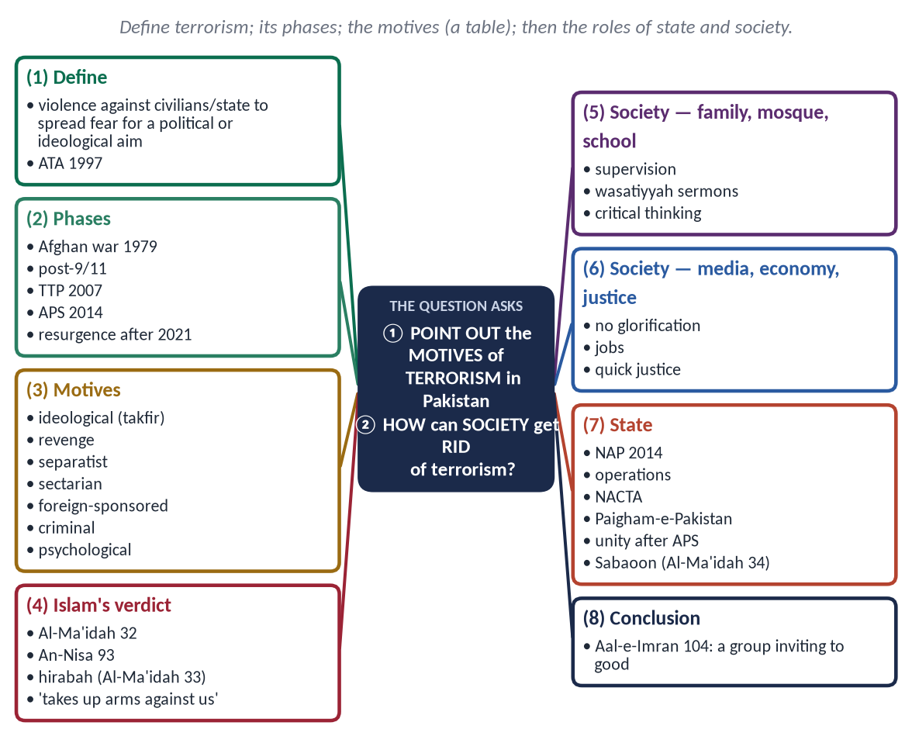
Figure 12 · The answer map: every branch is one numbered heading of the model answer below.

Decoding the question
- 'Motives of terrorism' — why terrorists act: the intentions and drivers behind their violence (not only general causes of extremism).
- 'How can the society get rid of terrorism' — the role of society's institutions (with the state), practically.

The model answer

(1) Introduction
Terrorism is violence against civilians or the state to create fear for a political or ideological aim. Pakistan's Anti-Terrorism Act (1997) defines it by such acts and aims. Pakistan has been among its greatest victims — over 80,000 killed between 2001 and 2018, and the Global Terrorism Index 2025 ranked it second most affected.
Extremism and terrorism differ: extremism is a mindset — rigid, exclusive, intolerant; terrorism is violent action meant to terrify. Every terrorist is an extremist, but not every extremist becomes a terrorist. The motives below explain the step from mind to bomb.

(2) The phases of terrorism in Pakistan
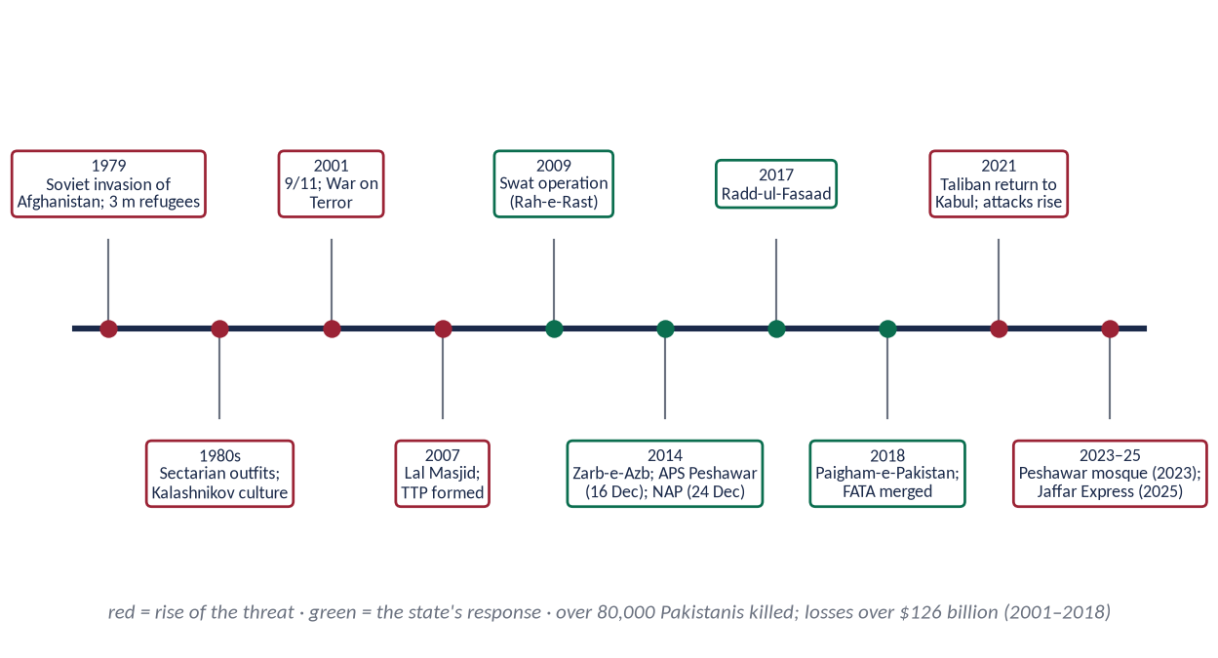
Figure 13 · Terrorism in Pakistan and the state's response.
- 1979–2001: the Afghan war — 3 million refugees, weapons, armed groups; sectarian violence.
- 2001–2007: post-9/11 — militants in the tribal areas; drone strikes.
- 2007–2014: TTP formed (December 2007); suicide bombings nationwide; Swat.
- 2014–2018: APS Peshawar (16 December 2014) → NAP; Zarb-e-Azb; Radd-ul-Fasaad — a sharp decline.
- 2021 onwards: resurgence after the Taliban's return to Kabul; the Peshawar mosque bombing (2023); the Jaffar Express hijacking (2025).

(3) The motives of terrorism
Motive | Explanation
Ideological | To impose their version of Shari'ah by force; takfir of the state and army
Revenge | For military operations, drone strikes and killed relatives
Separatist | Ethnic nationalist groups seeking separation, especially in Balochistan
Sectarian | Killing followers of other schools
Foreign-sponsored | Hostile agencies using militants as proxies (Pakistan cites the Jadhav case, 2016)
Criminal-economic | Extortion, kidnapping for ransom, smuggling and drug money
Psychological | Power, belonging, fame, the lure of 'martyrdom'

Motives, not only causes: poverty and injustice explain why an area is vulnerable; motives explain why a particular person or group chooses to kill. Most groups mix several — an ideological cover, a revenge story and a money supply.
The cost: over 80,000 Pakistanis killed and over 126 billion dollars lost (2001–2018); schools, shrines, mosques, churches and markets attacked; international cricket absent for a decade after 2009.

(4) Islam's verdict on terrorism
✦ QURAN
﴿… مَن قَتَلَ نَفۡسَۢا بِغَيۡرِ نَفۡسٍ أَوۡ فَسَادٖ فِي ٱلۡأَرۡضِ فَكَأَنَّمَا قَتَلَ ٱلنَّاسَ جَمِيعٗا وَمَنۡ أَحۡيَاهَا فَكَأَنَّمَآ أَحۡيَا ٱلنَّاسَ جَمِيعٗاۚ …﴾
“Whoever kills a soul — unless for a soul or for corruption in the land — it is as if he had slain mankind entirely; and whoever saves one, it is as if he had saved mankind entirely.” (Al-Ma'idah, Quran)
➜ Killing one innocent soul is like killing all mankind.

✦ QURAN
﴿وَمَن يَقۡتُلۡ مُؤۡمِنٗا مُّتَعَمِّدٗا فَجَزَآؤُهُۥ جَهَنَّمُ خَٰلِدٗا فِيهَا وَغَضِبَ ٱللَّهُ عَلَيۡهِ وَلَعَنَهُۥ وَأَعَدَّ لَهُۥ عَذَابًا عَظِيمٗا﴾
“But whoever kills a believer intentionally - his recompense is Hell, wherein he will abide eternally, and Allah has become angry with him and has cursed him and has prepared for him a great punishment.” (An-Nisa, Quran)
➜ Whoever kills a believer intentionally — his recompense is Hell.

✦ QURAN
﴿إِنَّمَا جَزَـٰٓؤُاْ ٱلَّذِينَ يُحَارِبُونَ ٱللَّهَ وَرَسُولَهُۥ وَيَسۡعَوۡنَ فِي ٱلۡأَرۡضِ فَسَادًا …﴾
“The recompense of those who wage war against Allah and His Messenger and strive to spread corruption (fasad) in the land …” (Al-Ma'idah, Quran)
➜ Those who wage war against Allah and His Messenger and spread fasad — the crime of hirabah.

✦ HADITH
مَنْ حَمَلَ عَلَيْنَا السِّلَاحَ فَلَيْسَ مِنَّا
“Whoever takes up arms against us is not of us.” (Al-Bukhari and Muslim)

The Hanafi position on rebels (baghy): those who take up arms against a lawful Muslim state are first called to dialogue and their grievances heard; if they persist, the state alone may fight them, only to end their rebellion — never to plunder or take revenge (Al-Hujurat 9).

(5) How society can get rid of terrorism

(i) The family
Time, love and supervision; teaching the Prophet's ﷺ mercy; awareness of children's online contacts — often the first to notice radicalisation.

(ii) The mosque and the ulema
Friday sermons on wasatiyyah, the sanctity of life and the prohibition of suicide; a code against hate speech; Paigham-e-Pakistan taught from the pulpit.
✦ HADITH
مَنْ قَتَلَ نَفْسَهُ بِحَدِيدَةٍ فَحَدِيدَتُهُ فِي يَدِهِ يَتَوَجَّأُ بِهَا فِي بَطْنِهِ فِي نَارِ جَهَنَّمَ خَالِدًا مُخَلَّدًا فِيهَا أَبَدًا
“Whoever kills himself with a weapon will stab himself with it in the Fire of Hell for ever.” (Muslim)
➜ The answer to the 'martyrdom' lie.

(iii) Schools, colleges and madrasas
Critical thinking; the Seerah of mercy; civic education; modern subjects in madrasas; debating and sports.

(iv) Media and social media
No glorification of terrorists (NAP point 11); counter-narratives; digital literacy — 'verify the news' (Al-Hujurat 6).

(v) The economy and civil society
Jobs, skills and loans for youth (Akhuwat's interest-free model); welfare through Zakat; youth clubs and volunteering.

(vi) Cooperation with the state
Reporting suspicious activity; refusing to shelter or fund militants; supporting the police.

(vii) National unity against terror
✦ HADITH
مَثَلُ الْمُؤْمِنِينَ فِي تَوَادِّهِمْ وَتَرَاحُمِهِمْ وَتَعَاطُفِهِمْ مَثَلُ الْجَسَدِ
“The believers in their love, mercy and compassion are like one body.” (Al-Bukhari and Muslim)

After APS Peshawar (2014), all political parties met and agreed on the National Action Plan within days — proof that a united society denies terrorists their aim of division. Care for victims' families and honour for the martyred police and soldiers keep that unity alive.

(viii) Rehabilitation — the door of repentance
✦ QURAN
﴿إِلَّا ٱلَّذِينَ تَابُواْ مِن قَبۡلِ أَن تَقۡدِرُواْ عَلَيۡهِمۡۖ فَٱعۡلَمُوٓاْ أَنَّ ٱللَّهَ غَفُورٞ رَّحِيمٞ﴾
“Except for those who return [repenting] before you apprehend them. And know that Allah is Forgiving and Merciful.” (Al-Ma'idah, Quran)
➜ 'Except those who repent before you overpower them — know that Allah is Forgiving, Merciful.'

Centres such as Sabaoon (Swat) have returned hundreds of young former militants to normal life through education, counselling and skills.

(6) The role of the state
- National Action Plan (2014), NACTA (2013), provincial counter-terrorism departments.
- Operations — Zarb-e-Azb, Radd-ul-Fasaad and later.
- FATF compliance (grey list exit, 2022) — terror financing choked.
- Justice reform, FATA merger (2018), border fencing, de-radicalisation (Sabaoon).
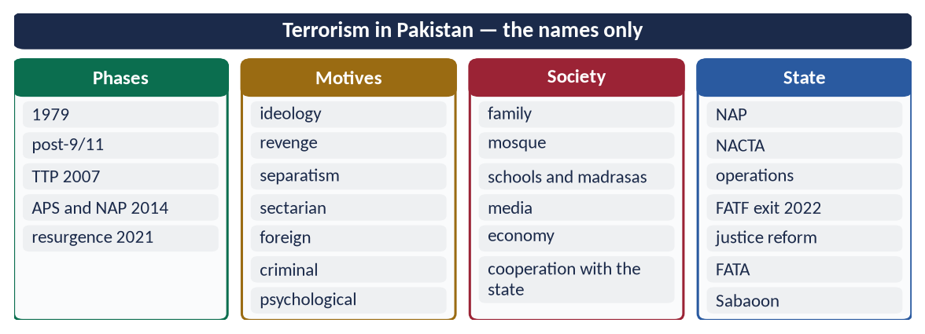
Figure 14 · At a glance — terrorism in Pakistan — the names only. The detail is in the sections above.

(7) Conclusion
✦ QURAN
﴿وَلۡتَكُن مِّنكُمۡ أُمَّةٞ يَدۡعُونَ إِلَى ٱلۡخَيۡرِ وَيَأۡمُرُونَ بِٱلۡمَعۡرُوفِ وَيَنۡهَوۡنَ عَنِ ٱلۡمُنكَرِۚ وَأُوْلَـٰٓئِكَ هُمُ ٱلۡمُفۡلِحُونَ﴾
“And let there be [arising] from you a nation inviting to [all that is] good, enjoining what is right and forbidding what is wrong, and those will be the successful.” (Aal-e-Imran, Quran)
➜ 'Let there be among you a group inviting to good, enjoining right and forbidding wrong.'

Terrorism in Pakistan has many motives — ideological, vengeful, separatist, sectarian, foreign and criminal. The state can defeat terrorists; only society can defeat terrorism, by closing every door through which young people are drawn into it.

Why this answer scores
- It defines terrorism and separates motives from general causes, in a table.
- The phases show command of Pakistan's recent history.
- 'How can society get rid' gets its own detailed heading, with the state's role alongside.

Answer 6 · The Motives of Extremism and How Society Can Get Rid of It by Following Islam (CSS 2023)
THE QUESTION · CSS 2023 · Q7 · 20 marks
What are the motives of extremism in Pakistan? How can the society get rid of extremism by following the teachings of Islam?

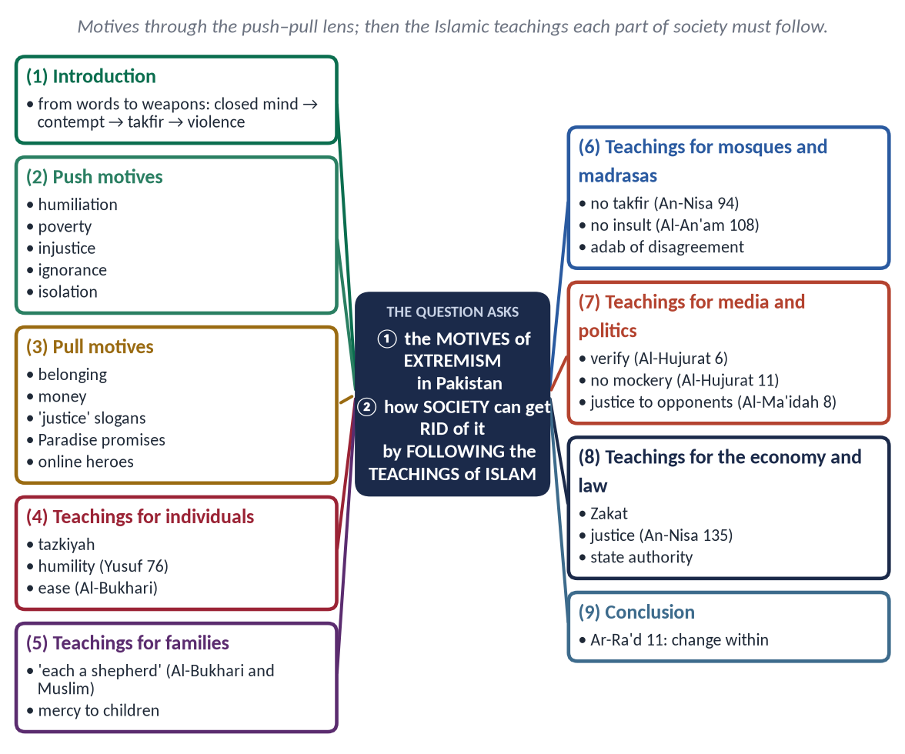
Figure 15 · The answer map: every branch is one numbered heading of the model answer below.

Decoding the question
- 'Motives of extremism' — why people become extremists: the drivers in their minds and circumstances.
- 'How can the society get rid of extremism by following the teachings of Islam' — each part of society, and the specific Islamic teaching it must follow.

The model answer

(1) Introduction
Extremism in Pakistan did not appear overnight; it grows in steps — a closed mind ('only we are right'), contempt for others, takfir, dehumanisation, and finally violence. To stop it, we must understand why people take the first step, and how Islam's own teachings can stop them.
✦ QURAN
﴿… وَفَوۡقَ كُلِّ ذِي عِلۡمٍ عَلِيمٞ﴾
“And over every possessor of knowledge is one more knowing.” (Yusuf, Quran)
➜ The humility that prevents the first step.

(2) The motives of extremism — push and pull

(i) Push factors — what drives people out of normal society
- Humiliation and grievance — injustice, loss of relatives in violence, perceived insults to religion.
- Poverty and unemployment — about two-thirds of Pakistanis are under 30, many without jobs.
- Injustice — slow courts, corruption, the powerful above the law.
- Ignorance — half-knowledge of religion without teachers and context.
- Isolation — lonely young people spending long hours online.

(ii) Pull factors — what draws them to extremist groups
- Belonging — a 'brotherhood' and a sense of purpose.
- Money, status and weapons.
- Simple slogans — 'Islamic justice', 'the enemies of Islam'.
- Promises of Paradise and 'martyrdom'.
- Online heroes — slick videos and secret communities.

(iii) Sectarian and political motives
Hatred of other schools, fed by hate literature; political polarisation that treats opponents as traitors.

(3) How society can get rid of extremism by following the teachings of Islam

(i) The individual — purification and humility
✦ QURAN
﴿قَدۡ أَفۡلَحَ مَن زَكَّىٰهَا ۝ وَقَدۡ خَابَ مَن دَسَّىٰهَا﴾
“He has succeeded who purifies it. And he has failed who instills it [with corruption].” (Ash-Shams, Quran)
➜ He has succeeded who purifies it, and failed who corrupts it.

✦ HADITH
إِنَّ الدِّينَ يُسْرٌ، وَلَنْ يُشَادَّ الدِّينَ أَحَدٌ إِلَّا غَلَبَهُ
“The religion is easy; no one makes it hard except that it overcomes him.” (Al-Bukhari)

(ii) The family — responsibility and mercy
✦ HADITH
كُلُّكُمْ رَاعٍ وَكُلُّكُمْ مَسْئُولٌ عَنْ رَعِيَّتِهِ
“Each of you is a shepherd, and each is responsible for his flock.” (Al-Bukhari and Muslim)

Time with children, knowledge of their friends and online life; mercy, not harshness.

(iii) The mosque and the madrasa — no takfir, no insult
✦ QURAN
﴿… إِذَا ضَرَبۡتُمۡ فِي سَبِيلِ ٱللَّهِ فَتَبَيَّنُواْ وَلَا تَقُولُواْ لِمَنۡ أَلۡقَىٰٓ إِلَيۡكُمُ ٱلسَّلَٰمَ لَسۡتَ مُؤۡمِنٗا …﴾
“O you who believe, when you go forth in the cause of Allah, verify, and do not say to one who offers you peace, 'You are not a believer.'” (An-Nisa, Quran)
➜ Do not say to one who offers you peace, 'You are not a believer.'

✦ QURAN
﴿وَلَا تَسُبُّواْ ٱلَّذِينَ يَدۡعُونَ مِن دُونِ ٱللَّهِ فَيَسُبُّواْ ٱللَّهَ عَدۡوَۢا بِغَيۡرِ عِلۡمٖۗ …﴾
“Do not insult those they invoke besides Allah, lest they insult Allah in enmity, without knowledge.” (Al-An'am, Quran)
➜ Do not insult what others hold sacred.

Teach the adab of disagreement — the Imams respected one another; Imam Malik refused to impose his Muwatta on all.

(iv) Schools and universities — knowledge and critical thinking
The Seerah of mercy; the Charter of Madinah; asking for evidence before believing.

(v) Media and politics — truth and justice
✦ QURAN
﴿يَـٰٓأَيُّهَا ٱلَّذِينَ ءَامَنُوٓاْ إِن جَآءَكُمۡ فَاسِقُۢ بِنَبَإٖ فَتَبَيَّنُوٓاْ أَن تُصِيبُواْ قَوۡمَۢا بِجَهَٰلَةٖ فَتُصۡبِحُواْ عَلَىٰ مَا فَعَلۡتُمۡ نَٰدِمِينَ﴾
“O you who have believed, if there comes to you a disobedient one with information, investigate, lest you harm a people out of ignorance and become, over what you have done, regretful.” (Al-Hujurat, Quran)
➜ If a sinful person brings news, verify it.

✦ QURAN
﴿… لَا يَسۡخَرۡ قَوۡمٞ مِّن قَوۡمٍ عَسَىٰٓ أَن يَكُونُواْ خَيۡرٗا مِّنۡهُمۡ وَلَا نِسَآءٞ مِّن نِّسَآءٍ عَسَىٰٓ أَن يَكُنَّ خَيۡرٗا مِّنۡهُنَّۖ …﴾
“Let not a people ridicule another people — perhaps they are better than them; nor let women ridicule other women — perhaps they are better than them.” (Al-Hujurat, Quran)
➜ Do not mock one another or call one another offensive names.

✦ QURAN
﴿… وَلَا يَجۡرِمَنَّكُمۡ شَنَـَٔانُ قَوۡمٍ عَلَىٰٓ أَلَّا تَعۡدِلُواْۚ ٱعۡدِلُواْ هُوَ أَقۡرَبُ لِلتَّقۡوَىٰۖ …﴾
“Do not let the hatred of a people lead you to be unjust. Be just; that is nearer to righteousness.” (Al-Ma'idah, Quran)
➜ Do not let hatred lead you to injustice.

(vi) The economy — justice and opportunity
✦ QURAN
﴿… كَيۡ لَا يَكُونَ دُولَةَۢ بَيۡنَ ٱلۡأَغۡنِيَآءِ مِنكُمۡۚ …﴾
“… so that it does not circulate only among the rich among you.” (Al-Hashr, Quran)
➜ So that wealth does not circulate only among the rich.

Zakat, jobs, skills and youth programmes remove the push of poverty.

(vii) The law — justice and the state's authority
✦ QURAN
﴿يَـٰٓأَيُّهَا ٱلَّذِينَ ءَامَنُواْ كُونُواْ قَوَّـٰمِينَ بِٱلۡقِسۡطِ شُهَدَآءَ لِلَّهِ وَلَوۡ عَلَىٰٓ أَنفُسِكُمۡ أَوِ ٱلۡوَٰلِدَيۡنِ وَٱلۡأَقۡرَبِينَۚ …﴾
“O you who believe, stand firmly for justice, as witnesses for Allah, even if it be against yourselves, your parents or your relatives.” (An-Nisa, Quran)
➜ Stand firm for justice.

✦ HADITH
مَنْ خَرَجَ مِنَ الطَّاعَةِ، وَفَارَقَ الْجَمَاعَةَ فَمَاتَ، مَاتَ مِيتَةً جَاهِلِيَّةً
“Whoever leaves obedience and separates from the community dies a death of Jahiliyyah.” (Muslim)
➜ No private armies — Paigham-e-Pakistan (2018).

(viii) Courage to protect the victim
✦ HADITH
انْصُرْ أَخَاكَ ظَالِمًا أَوْ مَظْلُومًا
“Help your brother, whether he is an oppressor or oppressed.” (Al-Bukhari)
➜ Helping the oppressor means stopping him.

When a mob killed a Sri Lankan factory manager in Sialkot (December 2021), a colleague, Malik Adnan, tried to shield him and was later honoured with the Tamgha-e-Shujaat — the conduct a society free of extremism rewards.

(4) What society and state must do together
Part of society | What it must do
Family | Supervise, love, teach mercy
Mosque and ulema | Wasatiyyah sermons; Paigham-e-Pakistan; no hate speech
Schools and madrasas | Critical thinking; modern subjects; the Seerah of mercy
Media | Counter-narratives; no glorification; digital literacy
Economy and civil society | Jobs, skills, interest-free loans, youth clubs
State | NAP; quick justice; madrasa registration; de-radicalisation (Sabaoon)

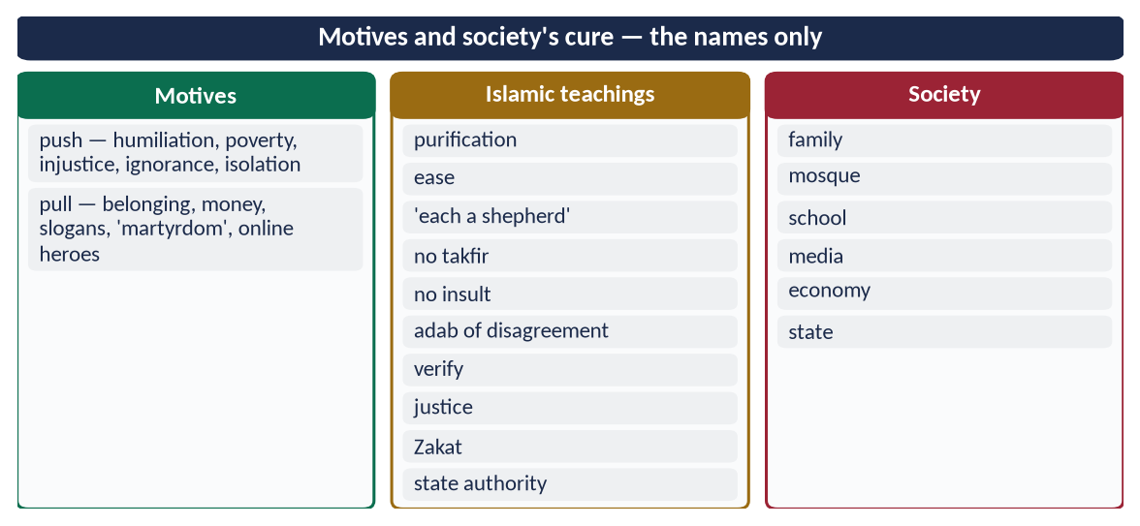
Figure 16 · At a glance — motives and society's cure — the names only. The detail is in the sections above.

(5) Conclusion
✦ QURAN
﴿… إِنَّ ٱللَّهَ لَا يُغَيِّرُ مَا بِقَوۡمٍ حَتَّىٰ يُغَيِّرُواْ مَا بِأَنفُسِهِمۡۗ …﴾
“Indeed, Allah will not change the condition of a people until they change what is in themselves.” (Ar-Ra'd, Quran)
➜ Allah does not change the condition of a people until they change what is in themselves.

The motives of extremism — grievance, poverty, ignorance and the lure of belonging — can be answered only by a society that lives the teachings of Islam: purification, mercy in the family, knowledge and humility in the mosque, truth in the media, justice in the economy and law.

Why this answer scores
- The push–pull analysis gives the motives depth beyond a simple list.
- Society's cure is organised institution by institution, each with its Islamic teaching — exactly 'by following the teachings of Islam'.
- A different shape from Answers 4 and 5 for a near-identical question.

Answer 7 · Eliminating Religious and Political Extremism through the Teachings of the Holy Prophet ﷺ (CSS 2024)
THE QUESTION · CSS 2024 · Q7 · 20 marks
How is it possible to eliminate the religious and political extremism in Pakistan in the light of the teachings of the Holy Prophet (ﷺ)? Explain.

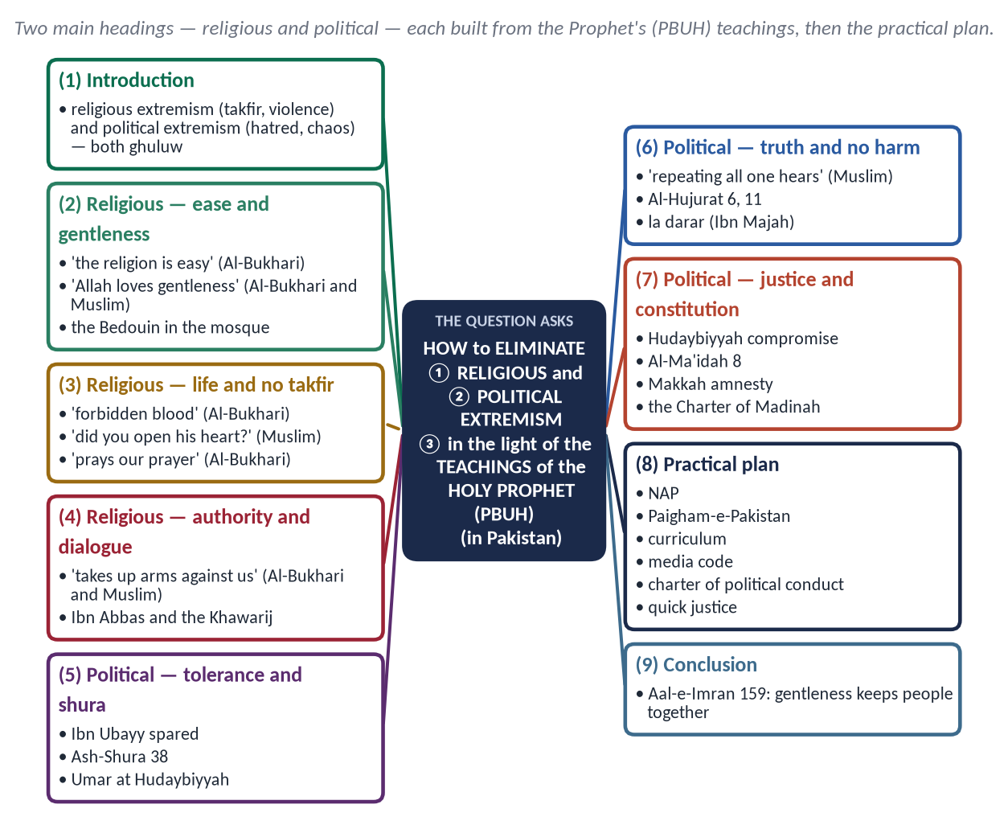
Figure 17 · The answer map: every branch is one numbered heading of the model answer below.

Decoding the question
- Two kinds of extremism — religious and political — each needs its own heading.
- 'In the light of the teachings of the Holy Prophet ﷺ' — the evidence must be mainly hadith and Seerah.
- 'How is it possible … in Pakistan' — end with a practical plan.

The model answer

(1) Introduction
Pakistan faces two extremisms: religious — takfir, sectarian hatred and violence in God's name; and political — hatred of opponents, abuse, fake news, street violence and contempt for institutions. Both are ghuluw (غُلُوّ) — going beyond limits — and both were answered by the Holy Prophet ﷺ in word and example.
✦ HADITH
إِيَّاكُمْ وَالْغُلُوَّ فِي الدِّينِ، فَإِنَّمَا أَهْلَكَ مَنْ كَانَ قَبْلَكُمُ الْغُلُوُّ فِي الدِّينِ
“Beware of extremism in religion, for it destroyed those before you.” (Al-Nasa'i and Ibn Majah)

(2) Eliminating religious extremism — the teachings of the Prophet ﷺ

(i) Ease, not hardship
✦ HADITH
إِنَّ الدِّينَ يُسْرٌ، وَلَنْ يُشَادَّ الدِّينَ أَحَدٌ إِلَّا غَلَبَهُ
“The religion is easy; no one makes it hard except that it overcomes him.” (Al-Bukhari)

He corrected the three men who vowed extreme worship — 'whoever turns from my Sunnah is not of me' — and asked Mu'adh, 'Are you a trouble-maker?' for lengthening the prayer (Al-Bukhari).

(ii) Gentleness in correction
✦ HADITH
إِنَّ اللَّهَ رَفِيقٌ يُحِبُّ الرِّفْقَ فِي الْأَمْرِ كُلِّهِ
“Allah is gentle and loves gentleness in every matter.” (Al-Bukhari and Muslim)

The Bedouin who urinated in the mosque was taught, not beaten.

(iii) The sanctity of life
✦ HADITH
لَنْ يَزَالَ الْمُؤْمِنُ فِي فُسْحَةٍ مِنْ دِينِهِ مَا لَمْ يُصِبْ دَمًا حَرَامًا
“The believer remains within the scope of his religion as long as he does not shed forbidden blood.” (Al-Bukhari)

Suicide is forbidden (An-Nisa 29); a suicide attacker 'stabs himself in the Fire' (Muslim).

(iv) No takfir
When Usamah (RA) killed a man who had said 'La ilaha illallah', the Prophet ﷺ asked, 'Did you open his heart?' (Muslim).
✦ HADITH
مَنْ صَلَّى صَلَاتَنَا، وَاسْتَقْبَلَ قِبْلَتَنَا، وَأَكَلَ ذَبِيحَتَنَا، فَذَلِكَ الْمُسْلِمُ
“Whoever prays our prayer, faces our qiblah and eats our slaughtered meat is a Muslim.” (Al-Bukhari)

(v) No private armies — the authority of the state
✦ HADITH
مَنْ حَمَلَ عَلَيْنَا السِّلَاحَ فَلَيْسَ مِنَّا
“Whoever takes up arms against us is not of us.” (Al-Bukhari and Muslim)

'Changing a wrong with the hand' belongs to lawful authority, not private groups.

(vi) Dialogue and the open door
The Prophet ﷺ did not punish Dhul-Khuwaysirah; Ali (RA) sent Ibn Abbas to reason with the Khawarij, and thousands returned. Those who lay down arms are accepted (Al-Ma'idah 34).

(3) Eliminating political extremism — the teachings of the Prophet ﷺ

(i) Tolerance of opposition
The Prophet ﷺ tolerated Abdullah ibn Ubayy, leader of the hypocrites, and refused to kill him: 'People will say Muhammad kills his companions' (Al-Bukhari).

(ii) Consultation and respect for dissent
✦ QURAN
﴿وَٱلَّذِينَ ٱسۡتَجَابُواْ لِرَبِّهِمۡ وَأَقَامُواْ ٱلصَّلَوٰةَ وَأَمۡرُهُمۡ شُورَىٰ بَيۡنَهُمۡ وَمِمَّا رَزَقۡنَٰهُمۡ يُنفِقُونَ﴾
“And those who have responded to their lord and established prayer and whose affair is [determined by] consultation among themselves, and from what We have provided them, they spend.” (Ash-Shura, Quran)
➜ Their affairs are by consultation among themselves.

He followed the majority at Uhud; he answered Umar's (RA) strong objections at Hudaybiyyah with patience.

(iii) Truthful speech — no propaganda
✦ HADITH
كَفَى بِالْمَرْءِ كَذِبًا أَنْ يُحَدِّثَ بِكُلِّ مَا سَمِعَ
“It is enough of a lie for a man to repeat everything he hears.” (Muslim)

✦ QURAN
﴿يَـٰٓأَيُّهَا ٱلَّذِينَ ءَامَنُوٓاْ إِن جَآءَكُمۡ فَاسِقُۢ بِنَبَإٖ فَتَبَيَّنُوٓاْ أَن تُصِيبُواْ قَوۡمَۢا بِجَهَٰلَةٖ فَتُصۡبِحُواْ عَلَىٰ مَا فَعَلۡتُمۡ نَٰدِمِينَ﴾
“O you who have believed, if there comes to you a disobedient one with information, investigate, lest you harm a people out of ignorance and become, over what you have done, regretful.” (Al-Hujurat, Quran)
➜ If a sinful person brings news, verify it.

✦ QURAN
﴿… لَا يَسۡخَرۡ قَوۡمٞ مِّن قَوۡمٍ عَسَىٰٓ أَن يَكُونُواْ خَيۡرٗا مِّنۡهُمۡ وَلَا نِسَآءٞ مِّن نِّسَآءٍ عَسَىٰٓ أَن يَكُنَّ خَيۡرٗا مِّنۡهُنَّۖ …﴾
“Let not a people ridicule another people — perhaps they are better than them; nor let women ridicule other women — perhaps they are better than them.” (Al-Hujurat, Quran)
➜ Do not mock one another or call one another offensive names.

(iv) Compromise for the common good
At Hudaybiyyah (628) the Prophet ﷺ accepted that 'Messenger of Allah' be struck from the treaty and agreed to terms that seemed unequal — for the sake of peace. The Quran called the result 'a clear victory' (Al-Fath 1). Politics by compromise, not by 'all or nothing', is the Sunnah.

(v) No harm to public life
✦ HADITH
لَا ضَرَرَ وَلَا ضِرَارَ
“There is to be no harm and no returning of harm.” (Ibn Majah)
➜ No burning of property, no blocking of roads, no attacks on institutions.

(vi) Justice to opponents
✦ QURAN
﴿… وَلَا يَجۡرِمَنَّكُمۡ شَنَـَٔانُ قَوۡمٍ عَلَىٰٓ أَلَّا تَعۡدِلُواْۚ ٱعۡدِلُواْ هُوَ أَقۡرَبُ لِلتَّقۡوَىٰۖ …﴾
“Do not let the hatred of a people lead you to be unjust. Be just; that is nearer to righteousness.” (Al-Ma'idah, Quran)
➜ Do not let the hatred of a people lead you to injustice — be just.

(vii) Forgiveness instead of revenge
At Ta'if he prayed for those who stoned him instead of cursing them; at the Conquest of Makkah (630) he told his bitterest opponents, 'No blame on you today; go, you are free.' Political victory without revenge ended decades of hostility — the opposite of today's culture of vendetta.

(viii) A constitution for all
The Charter of Madinah bound different communities to one agreed law and one arbiter — the model of settling political differences through the Constitution and courts.

(4) The practical plan for Pakistan
Area | Measures
Religious | NAP (2014) against hate speech and militias; Paigham-e-Pakistan in curricula; madrasa registration and modern subjects; de-radicalisation (Sabaoon)
Political | A charter of political conduct; respect for election results and courts; party training in tolerance
Media | A code against hate and fake news; fact-checking; PECA 2016 applied fairly
Education | The Seerah of mercy; the Charter of Madinah; critical thinking; debating culture
Justice | Quick trials; one law for all; punishment of mob violence (Sialkot 2021, Jaranwala 2023)
Youth | Jobs, skills, sports and civic participation

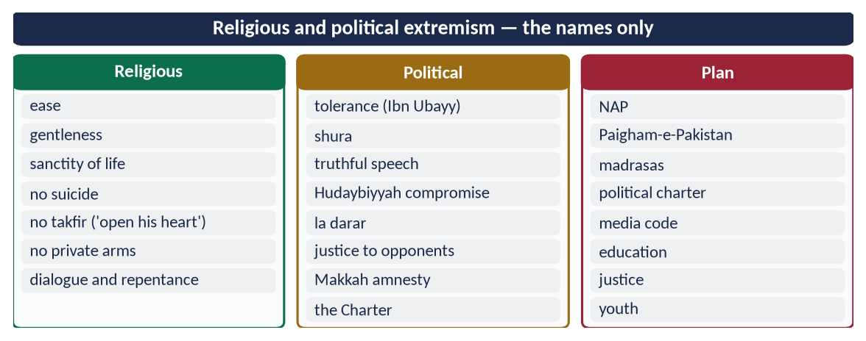
Figure 18 · At a glance — religious and political extremism — the names only. The detail is in the sections above.

(5) Conclusion
✦ QURAN
﴿فَبِمَا رَحۡمَةٖ مِّنَ ٱللَّهِ لِنتَ لَهُمۡۖ وَلَوۡ كُنتَ فَظًّا غَلِيظَ ٱلۡقَلۡبِ لَٱنفَضُّواْ مِنۡ حَوۡلِكَۖ …﴾
“So by mercy from Allah you were gentle with them; had you been harsh and hard-hearted, they would have scattered from around you.” (Aal-e-Imran, Quran)
➜ By Allah's mercy you were gentle with them; had you been harsh and hard-hearted, they would have scattered from around you.

The Prophet ﷺ answered religious extremism with ease, mercy, the sanctity of life and the refusal of takfir; he answered political extremism with tolerance, consultation, truth and justice. If Pakistan's pulpits, parties, media and courts follow these teachings, both extremisms can be eliminated.

Why this answer scores
- Religious and political extremism each get a full heading — both limbs of the question.
- The evidence is mainly hadith and Seerah, as 'teachings of the Holy Prophet ﷺ' demands.
- A practical plan table answers 'how is it possible … in Pakistan'.

Answer 8 · Sectarianism and Polarisation in the Muslim World: Causes and Solutions (CSS 2026)
THE QUESTION · CSS 2026 · Q7 · 20 marks
Examine the causes of sectarianism and polarization in the Muslim World. Suggest solutions in the light of Islamic teachings.

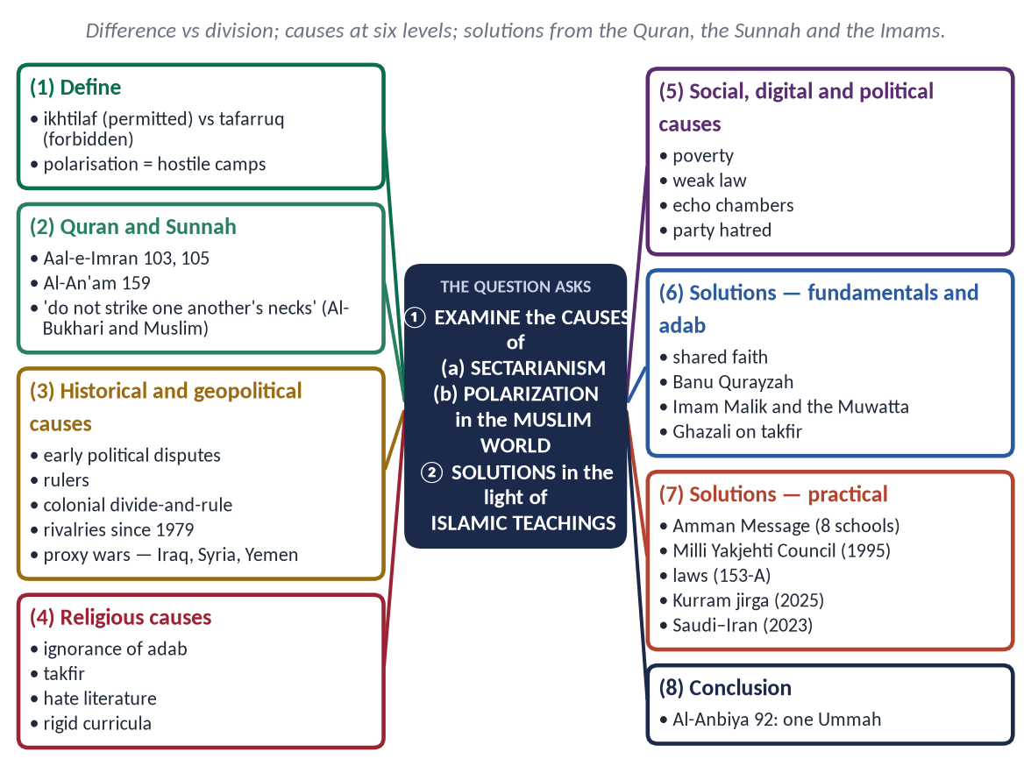
Figure 19 · The answer map: every branch is one numbered heading of the model answer below.

Decoding the question
- 'Examine the causes' — analyse, not merely list: historical, geopolitical, religious, social, digital and political causes.
- Two words — sectarianism (religious division) and polarization (hostile camps of every kind).
- 'Solutions in the light of Islamic teachings' — Quran, Sunnah, the conduct of the Imams, and practical steps.

The model answer

(1) Introduction
Islam permits difference (ikhtilaf, اِخْتِلَاف) — the Imams differed on hundreds of questions — but forbids division (tafarruq, تَفَرُّق) that turns difference into hatred and war. Sectarianism is that division in religion; polarization is its wider form — society split into hostile religious, political and ideological camps.
✦ QURAN
﴿وَٱعۡتَصِمُواْ بِحَبۡلِ ٱللَّهِ جَمِيعٗا وَلَا تَفَرَّقُواْۚ وَٱذۡكُرُواْ نِعۡمَتَ ٱللَّهِ عَلَيۡكُمۡ إِذۡ كُنتُمۡ أَعۡدَآءٗ فَأَلَّفَ بَيۡنَ قُلُوبِكُمۡ فَأَصۡبَحۡتُم بِنِعۡمَتِهِۦٓ إِخۡوَٰنٗا …﴾
“And hold firmly to the rope of Allah all together and do not become divided. Remember Allah's favour upon you: you were enemies, and He brought your hearts together, and by His favour you became brothers.” (Aal-e-Imran, Quran)
➜ 'Hold fast to the rope of Allah all together and do not be divided.'

✦ QURAN
﴿إِنَّ ٱلَّذِينَ فَرَّقُواْ دِينَهُمۡ وَكَانُواْ شِيَعٗا لَّسۡتَ مِنۡهُمۡ فِي شَيۡءٍۚ إِنَّمَآ أَمۡرُهُمۡ إِلَى ٱللَّهِ ثُمَّ يُنَبِّئُهُم بِمَا كَانُواْ يَفۡعَلُونَ﴾
“Indeed, those who have divided their religion and become sects - you, [O Muhammad], are not [associated] with them in anything. Their affair is only [left] to Allah; then He will inform them about what they used to do.” (Al-An'am, Quran)
➜ Those who divided their religion and became sects — you have nothing to do with them.

✦ HADITH
لَا تَرْجِعُوا بَعْدِي كُفَّارًا يَضْرِبُ بَعْضُكُمْ رِقَابَ بَعْضٍ
“Do not become disbelievers after me, striking one another's necks.” (Al-Bukhari and Muslim)
➜ The Farewell Pilgrimage warning.

(2) The causes of sectarianism and polarization

(i) Historical
Early political disputes over leadership hardened over centuries into theological identities; rulers used divisions to control people; colonial 'divide and rule' counted and separated communities by sect.

(ii) Geopolitical
Since 1979, regional powers have backed rival groups; proxy wars in Iraq (from 2003), Syria (from 2011) and Yemen (from 2014–15) killed hundreds of thousands and displaced millions. Pakistan, too, felt this through foreign funding of sectarian groups in the 1980s–90s.

(iii) Religious
- Ignorance of the adab of disagreement.
- Takfir of other schools.
- Hate literature, inflammatory sermons, misuse of loudspeakers.
- Rigid curricula that teach only the refutation of others.

(iv) Social and economic
Poverty and frustration channelled into group hatred; weak rule of law — target killings go unpunished (Pakistan's hotspots: Karachi, Quetta, Jhang, Gilgit-Baltistan, Kurram).

(v) Digital
Social media echo chambers — algorithms reward outrage; fake videos and quotes spread in minutes.

(vi) Political
Party politics built on hatred; the language of 'traitor' and 'infidel' in political speech; distrust of institutions — the core of polarization.

(vii) The consequences
Hundreds of thousands killed in sectarian wars in Iraq, Syria and Yemen; target killings of doctors, lawyers and scholars in Pakistan; a paralysed OIC; and weakened support for Palestine and Kashmir. Division turns the Ummah's strength against itself.

(3) The solutions in the light of Islamic teachings

(i) Unity on the fundamentals
One Allah, one Prophet ﷺ, one Quran, one qiblah, the same pillars and articles of faith — what unites is far greater than what divides.
✦ QURAN
﴿إِنَّ هَٰذِهِۦٓ أُمَّتُكُمۡ أُمَّةٗ وَٰحِدَةٗ وَأَنَا۠ رَبُّكُمۡ فَٱعۡبُدُونِ﴾
“Indeed this, your religion, is one religion, and I am your Lord, so worship Me.” (Al-Anbiya, Quran)
➜ 'This Ummah of yours is one Ummah.'

(ii) The adab of disagreement — the example of the Imams
- At Banu Qurayzah, the Prophet ﷺ approved two different readings of one command (Al-Bukhari).
- Imam Malik refused Caliph Harun al-Rashid's offer to impose his Muwatta on the empire.
- The four Imams respected one another despite their differences.
✦ SCHOLARLY VIEW
Imam al-Ghazali · Faysal al-Tafriqah; Al-Iqtisad
To spare a thousand disbelievers by mistake is lighter than to shed the blood of one Muslim by mistake.
➜ The classical caution against takfir.

(iii) No takfir
✦ QURAN
﴿… إِذَا ضَرَبۡتُمۡ فِي سَبِيلِ ٱللَّهِ فَتَبَيَّنُواْ وَلَا تَقُولُواْ لِمَنۡ أَلۡقَىٰٓ إِلَيۡكُمُ ٱلسَّلَٰمَ لَسۡتَ مُؤۡمِنٗا …﴾
“O you who believe, when you go forth in the cause of Allah, verify, and do not say to one who offers you peace, 'You are not a believer.'” (An-Nisa, Quran)
➜ Do not say to one who offers you peace, 'You are not a believer.'

The Amman Message (2004–2005), endorsed by some 200 scholars, recognised eight schools of law and forbade declaring their followers disbelievers.

(iv) Reconciliation
✦ QURAN
﴿إِنَّمَا ٱلۡمُؤۡمِنُونَ إِخۡوَةٞ فَأَصۡلِحُواْ بَيۡنَ أَخَوَيۡكُمۡۚ وَٱتَّقُواْ ٱللَّهَ لَعَلَّكُمۡ تُرۡحَمُونَ﴾
“The believers are but brothers, so make settlement between your brothers. And fear Allah that you may receive mercy.” (Al-Hujurat, Quran)
➜ The believers are but brothers, so make peace between your brothers.

The Kurram peace agreement (January 2025), reached through a grand jirga after the November 2024 violence, shows the method.

(v) Education
Curricula on the adab of disagreement, comparative fiqh taught with respect, the history of the Imams' friendship, and critical thinking.

(vi) Law and governance
Enforcement against hate speech and sectarian violence — PPC 153-A, 295-A, the Anti-Terrorism Act 1997; loudspeaker laws (Punjab, 2015); a ban on armed groups (NAP).

(vii) Joint platforms
The Milli Yakjehti Council (1995); Paigham-e-Pakistan (2018), signed by scholars of all schools; codes of conduct for Muharram and religious gatherings.

(viii) Against political polarization
Verify news (Al-Hujurat 6); no mockery (Al-Hujurat 11); justice to opponents (Al-Ma'idah 8); consultation (Ash-Shura 38); a charter of political conduct.

(ix) At the level of the Muslim world
End proxy wars; dialogue through the OIC; the Saudi–Iran rapprochement brokered in Beijing (March 2023) as a model.
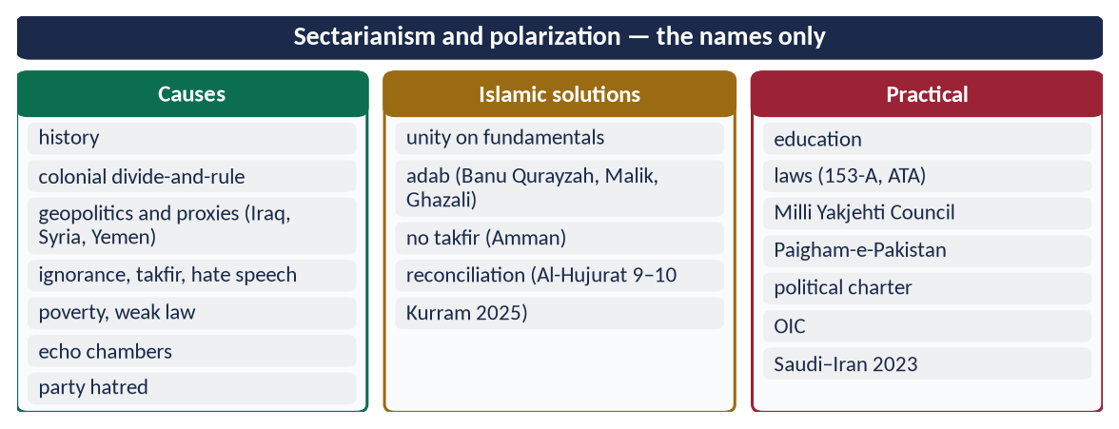
Figure 20 · At a glance — sectarianism and polarization — the names only. The detail is in the sections above.
A simple rule for every Muslim: differ with evidence and respect, never with abuse or takfir; judge a person by his own words, not by his group's label; and leave final judgement to Allah.

(4) Conclusion
✦ QURAN
﴿وَأَطِيعُواْ ٱللَّهَ وَرَسُولَهُۥ وَلَا تَنَٰزَعُواْ فَتَفۡشَلُواْ وَتَذۡهَبَ رِيحُكُمۡۖ وَٱصۡبِرُوٓاْۚ إِنَّ ٱللَّهَ مَعَ ٱلصَّـٰبِرِينَ﴾
“And obey Allah and His Messenger, and do not dispute and [thus] lose courage and [then] your strength would depart; and be patient. Indeed, Allah is with the patient.” (Al-Anfal, Quran)
➜ 'Do not dispute, lest you lose courage and your strength departs.'

Sectarianism and polarization grow from history, geopolitics, ignorance, injustice and digital outrage. Islam's answer is to keep the difference and drop the division: unity on the fundamentals, the adab of the Imams, no takfir, reconciliation, just laws and a responsible media. That is the path from a divided Ummah back to 'one body'.

Why this answer scores
- It examines causes at six levels, covering both sectarianism and polarization.
- Solutions come from the Quran, Sunnah and the Imams, then practical steps.
- Current cases (Kurram 2025, Saudi–Iran 2023) show up-to-date knowledge.

